Linkage disequilibrium mapping of the replicated type 2 diabetes linkage signal on chromosome 1q

STUDY SAMPLES
Discovery samples
Eight populations were studied: Amish, French, Utah, UK, Hong Kong, Shanghai, Pima and African American. Detailed descriptions are available elsewhere for each of the above samples (1, 2). Details about health condition (T2D, non-T2D, or unknown), age at diagnosis or study and body mass index (BMI) are reported in Supplementary Table 1 for the 1,526 cases and 1,653 controls, for whom genotyping data were used in the final analysis.
The consortium samples have been chosen to maximize the chances of detecting 1q susceptibility genes. They have been selected to fulfil the following criteria: (a) provenance from populations for which there is existing evidence of 1q linkage, (b) case selection from multiplex families contributing to the linkage signal (wherever possible), (c) ethnically-matched control samples ascertained as either non-diabetic or as population controls.

Replication samples
We used 5 separate replication sets, all of European-descent. The UKT2DGC (UK Type 2 Diabetes Genetics Consortium) replication sample consists of 4,014 T2D cases and 4,906 controls originating from Dundee, Scotland, UK, previously described as RS1 and RS3, together with the third tranche of cases and controls (“RS4”) ascertained more recently using the same criteria (3,4). A second UK replication set consists of 558 T2D cases from the OxGN cohort and 2,035 controls from the 1958 UK Birth Cohort, not included in the WTCCC control set. A detailed description of these samples is available elsewhere (3,4).
We also made use of the WTCCC, DGI and FUSION T2D genome-wide association (GWA) scans as additional (in silico) replication sets.

The WTCCC study examined 1,924 cases and 2,938 controls. This WTCCC case group includes 429 cases from the Warren 2 sib-pair consortium collection (5) that are also included in the 1q consortium UK sample set. These samples were therefore excluded from the WTCCC replication set we used for this study, leaving an independent WTCCC set of 1,495 cases and 2,938 controls (3,6). Genotyping of the WTCCC UK T2D cases and UK populations-based controls was performed with the GeneChip 500K Human Mapping Array Set (Affymetrix chip), which comprises 500,568 SNPs, at the Affymetrix R&D facility. Details about the quality control can be found in the previously published work (3,6).
The DGI, FUSION studies were extensively described in previous publications (4, 7,8) including their study design, quality control of genome-wide data and analytical methods.

SNP SELECTION AND GENOTYPING

SNP selection for Golden Gate assays
Single nucleotide polymorphisms (SNPs) were selected for genotyping on Illumina’s 1536-plex GoldenGate™ assays (OPAs) using a sequential design. For the first two Illumina OPAs, selection was based on HapMap phase I and dbSNP information available at the time, leading to a median SNP spacing of ~4.3 kb for the core 1q region of 13.5 Mb (150Mb-163.5Mb). Candidate polymorphisms (SNPs in candidate genes) were also included. SNPs in the third OPA were selected to cover an extended region of 21.3 Mb (148.1Mb-169.4Mb) based on the same criteria. SNPs for the fourth OPA were selected using HapMap phase II (9) CEU, CHB and JPT genotypes. A tagging approach was followed (9,10) to ensure common variation capture in the core region and to extend coverage to the centromeric and the telomeric flank boundaries of 147Mb and 169.7 Mb respectively. A further set of 35 candidate SNPs, passing the Illumina design score as described below in Quality Control section, were included. Eleven SNPs with some evidence for positive selection based on the HapMap (9,11), copy number variation tags and genomic control SNPs were also included in the fourth OPA. Duplicate SNPs were included across OPAs to ensure genotyping consistency. There were 121 SNPs duplicated in total; four SNPs (rs6660701, rs4971100, rs862996 and rs411089) appeared in 3 different OPAs. A total number of 6,023 unique SNPs were genotyped on 4 OPAs in total.

Golden Gate genotyping
Genotyping was performed using high-throughput technology available from the Illumina Golden Gate Assay™ assays (each 1536-plex allele-specific extension arrays) at the Wellcome Trust Sanger Institute, Wellcome Trust Genome Campus, Hinxton, UK. Four assays were genotyped sequentially for 4,472 individuals across 8 populations, producing a total of 27.45x10⁶ genotypes. For the purposes of this study 352 genotyped individuals were excluded from the analysis, consisting of all related individuals, Amish IGT cases, non-European origin individuals from French cohort and UK samples plated on the non-UK plates.

Genotype quality control

We followed a stepwise genotype quality control (QC) approach. Individual QC checks were carried out on a population-specific basis. Each QC step could change the status of samples or SNPs from “pass” to “suspect” or “fail”. SNPs and samples with a “fail” or more than one “suspect” status were excluded from further analyses.

Sample-specific QC
Samples with missing rates > 70% were excluded from further analysis. This threshold allowed for a sample to have failed genotyping across all SNPs on one of the four GoldenGate OPAs (for example due to low DNA concentration issues). On average, 91.7% of genotyped samples (lowest 88.5% in Pima, highest 93.5% in Utah) passed this threshold giving a total of 3,778 individuals, including 3,179 subjects used in the case-control analyses and 599 Pima Indians investigated in the family-based analyses.

SNP-specific QC

Genotypes with Illumina quality scores lower than 0.25 were treated as missing. Duplicate sample concordance rates (5 duplicates per 96-well plate) were checked for each variant and discordant SNPs were excluded from further analysis. SNPs with genotype missing rates >20% were set to “fail”. Exact tests for deviation from Hardy-Weinberg equilibrium were performed in cases and controls separately in each population. If the exact HWE p value was <0.01 in cases or 10⁻⁴< p<0.01 in controls the SNP was assigned “suspect” status; SNPs with p <10⁻⁴ in controls were assigned “fail” status. In total, 0.05-0.46% of SNPs were excluded based on the exact HWE criterion in each of the 8 populations. The arrangement of samples on 96-well plates was a mixture of population-specific cases and controls. We compared genotype frequencies across plates within the same population and assigned SNPs displaying differences (p<0.05) a “suspect” status. We additionally treated each plate as a case-control stratum in an across-plate meta-analysis, and examined heterogeneity statistics assigning “suspect” status to SNPs with evidence for significant heterogeneity (p<0.05). We also excluded monomorphic SNPs from further analyses; the number of monomorphic SNPs varied from 2.5% to 5.9% in 6 of the 1qC populations and was higher (~11.2%) in the two smaller sample sets of East Asian origin. A SNP failing QC in more than one population was excluded from downstream analyses across all datasets. A total of 5,290 out of 6,023 unique genotyped SNPs were included in the final analyses.

Replication genotyping and Quality Control
We genotyped rs7538490, mapping to the NOS1AP gene, and rs11264371 (r²~1.0 with rs11264372) , mapping to PKLR/ASH1L region in 4,572 T2D cases and 6,941 controls from the UK replication samples (W2C v 58BC; UKT2DGC) using Applied Biosystems Taqman® genotyping assays (Applied Biosystems, Foster City, California, USA). Fluorescence of the resulting PCR products was detected using a 7900HT Sequence Detection System (Applied Biosystems, Foster City, California, USA). Genotype success rates exceeded 95% for rs7538490 and rs11264371. Based on data from duplicate samples (5 duplicates for 384 plate on average), the discrepancy error rate was estimated to be <1% for both variants. There was no departure from Hardy– Weinberg equilibrium (p>0.05) for these SNPs.

Statistical Analysis
Power estimates
Here we explain in more detail some of the basis for the power calculations supplied in the main text.
The objective of this study was to identify variants that are causal for the 1q linkage signal, and the study was powered accordingly.

A reasonable estimate of the effect size of the 1q linkage signal (estimated from the original linkage studies) is a locus-specific sibling relative risk (λs) of ~1.2. Smaller effect sizes than this are unlikely to have been detectable by linkage at all in the sample sizes typically examined. Effect size estimates in single linkage studies are almost always subject to substantial upward bias (12): here, we assume that the extent of any upward bias is, given the extent of replication, relatively modest, and therefore assume that the linkage signal we need to explain has a locus-specific sibling relative risk (λs) of ~1.15.
Linkage is poorly-powered compared to association when the variants typed are in strong LD with those which are etiological. Indeed, a λs of 1.15 is consistent with a multiplicative locus of OR=3 and control MAF=5%: such a variant is detectable (80% power, α=5x10⁻⁶) -- under the most optimistic assumptions -- in just 330 unselected case-control pairs, or as few as 103 pairs if the cases are selected to come from multiplex families (as in present study).
However, it seems highly unlikely that the recent round of GWA studies could have missed variants with such strong effects. Therefore, a more realistic model might attribute the linkage signal to the effects of multiple loci within the 1q region. The extent of locus heterogeneity is impossible to estimate with any certainty, but if we assume that there are three loci of equal effect acting in additive fashion, then we can distribute the linkage signal between those three loci, each having a locus-specific λs of ~1.0475. This effect still exceeds that of TCF7L2 (λs ~1.03). Such an effect would be achieved (for example) though variants with MAF of 1.2% and allelic OR of 3, or MAF of 20% and allelic OR of 1.6. Under the same assumptions as above (80% power, α=5x10⁻⁶), cases selected from multiplex families), such loci would require between ~295 and 370 case-control pairs, sample sizes readily exceeded in the present study for European samples at least.

Population-specific analyses
SNPs with minor allele frequency lower than 1% in each population were excluded from further analysis. Population-specific single-point analyses were performed using SNPTEST software (13) to undertake Cochran-Armitage 1df tests for trend (additive model). Dominant and recessive models were also evaluated using the Mantel-Haentzel test of association. Genomic control inflation parameters (GC(λ)) was estimated for each population within the studied 22.7Mb region as a measure of population structure and cryptic relatedness: for the Amish and Pima data sets (for which this parameter exceeded 1.1) association test results were revised using the population-specific lambda. Analyses in the larger independent Pima family-based association data set were performed using GEE (generalized estimating equations, 14) to account for family membership (using a general association approach, which could still be potentially influenced by population stratification, but is more powerful than usual within-family test).

Imputation
Imputation was performed separately in each group of cases and controls using the IMPUTE programme (13), which imputes unobserved genotypes using information from the directly genotyped SNPs, the set of HapMap Phase II haplotypes, and fine-scale recombination maps. Genotypes for samples of European origin were imputed using CEU haplotypes; genotypes for Hong Kong, Shanghai and Pima samples were imputed using CHB and JPT as reference and those for African American samples using YRI. In the 22.7Mb studied region an additional ~16,400 SNPs could be imputed for Europeans, ~19,400 for African origin individuals, and ~21,900 for East Asians. A SNP was considered to have been successfully imputed if the average maximum posterior call of imputation exceeded 85%. Imputed SNPs with departure from HWE (p<10-4), minor allele frequency >0.01 in either cases or controls in each sample, and SNPs with less than 40% of statistical information (proper_info, 13) for the estimate of allele frequency were excluded from further analysis. After imputation and subsequent QC of the imputed data the total number of genotyped and imputed SNPs available in each sample set ranged from ~16,500 in Pima to ~20,850 in African American cohort, on average European origin samples had ~18,200 SNPs available for analysis.

Imputation and Quality control in the independent WTCCC sample

Sample genotype call rates for the independent WTCCC sample consisting of 1495/2938 cases/controls included in this analysis were all >0.97 (as per the WTCCC QC criteria, 6). In the studied 1q region, 3,419 SNPs successfully passed QC criteria within the WTCCC dataset used for replication purposes. Quality control criteria included Hardy-Weinberg Equilibrium [HWE] p>10⁻⁴ in T2D cases and controls, call frequency>0.95, minor allele frequency [MAF]>0.01, and good clustering. For directly genotyped SNPs with MAF from 0.05 to 0.01 the call frequency of ≥0.99 was applied in addition. Genome-wide imputation based on HapMap CEU data was used to cover untyped common variants. In the 1q region, an additional set of 15,721 SNPs were imputed (and passed QC), giving a total of 19,140 SNPs in the region for the independent WTCCC sample.

Meta-analysis
A series of nested meta-analyses of directly genotyped and imputed SNPs in the 22.7Mb 1q region were performed for: (a) European samples only including Amish, French, Utah and UK samples (“4-way”); (b) for samples of non-African ancestry (“7-way”); and (c) all 8 samples (“8-way”). SNPs were included in the meta-analyses carried out if they were successfully genotyped/imputed in all populations contributing to a particular meta-analysis. Combined Odds Ratios and Confidence Intervals for directly genotyped and imputed SNPs for independent samples were estimated applying a fixed-effects Mantel-Haenszel method for the additive model as implemented in SNPTEST. Significant departures from expectation in the distributions of test statistics within 1q region, observed for Pima and Amish samples, were adjusted using Genomic Control methods. Meta-analyses were performed using fixed effects weighted z-score method for combining p-values. Heterogeneity was tested using the Cochran Q statistic as implemented in STATA.

Replication analyses
Association analyses of the replication SNPs (generating ORs and 95%CIs) were performed in STATA (version 10, Stata, College Station, TX) and in PLINK version 1.04 (155). The Cochrane-Armitage test was applied for the additive model and Fisher’s exact tests were carried out for the dominant and recessive models. Replication SNPs, imputed in the WTCCC, DGI and FUSION GWAs, were analysed as described previously (4,7,8). Joint meta-analysis of replication and discovery sets was performed using inverse-variance fixed effects method combining odds ratios and confidence intervals as implemented in STATA.

References
- Zeggini E, Damcott CM, Hanson RL, Karim MA, Rayner NW, Groves CJ, Baier LJ, Hale TC, Hattersley AT, Hitman GA, Hunt SE, Knowler WC, Mitchell BD, Ng MC, O'Connell JR, Pollin TI, Vaxillaire M, Walker M, Wang X, Whittaker P, Xiang K, Jia W, Chan JC, Froguel P, Deloukas P, Shuldiner AR, Elbein SC, McCarthy MI: Variation within the gene encoding the upstream stimulatory factor 1 does not influence susceptibility to type 2 diabetes in samples from populations with replicated evidence of linkage to chromosome 1q. Diabetes 55:2541-2548, 2006
- Raffel LJ, Robbins DC, Norris JM, Boerwinkle E, DeFronzo RA, Elbein SC, Fujimoto W, Hanis CL, Kahn SE, Permutt MA, Chiu KC, Cruz J, Ehrmann DA, Robertson RP, Rotter JI, Buse J: The GENNID Study. A resource for mapping the genes that cause NIDDM. Diabetes Care 19:864-872, 1996
- Zeggini E, Weedon MN, Lindgren CM, Frayling TM, Elliott KS, Lango H, Timpson NJ, Perry JR, Rayner NW, Freathy RM, Barrett JC, Shields B, Morris AP, Ellard S, Groves CJ, Harries LW, Marchini JL, Owen KR, Knight B, Cardon LR, Walker M, Hitman GA, Morris AD, Doney AS, McCarthy MI, Hattersley AT: Replication of genome-wide association signals in UK samples reveals risk loci for type 2 diabetes. Science 316:1336-1341, 2007
- Zeggini E, Scott LJ, Saxena R, Voight BF, Marchini JL, Hu T, de Bakker PI, Abecasis GR, Almgren P, Andersen G, Ardlie K, Boström KB, Bergman RN, Bonnycastle LL, Borch-Johnsen K, Burtt NP, Chen H, Chines PS, Daly MJ, Deodhar P, Ding CJ, Doney AS, Duren WL, Elliott KS, Erdos MR, Frayling TM, Freathy RM, Gianniny L, Grallert H, Grarup N, Groves CJ, Guiducci C, Hansen T, Herder C, Hitman GA, Hughes TE, Isomaa B, Jackson AU, Jørgensen T, Kong A, Kubalanza K, Kuruvilla FG, Kuusisto J, Langenberg C, Lango H, Lauritzen T, Li Y, Lindgren CM, Lyssenko V, Marvelle AF, Meisinger C, Midthjell K, Mohlke KL, Morken MA, Morris AD, Narisu N, Nilsson P, Owen KR, Palmer CN, Payne F, Perry JR, Pettersen E, Platou C, Prokopenko I, Qi L, Qin L, Rayner NW, Rees M, Roix JJ, Sandbaek A, Shields B, Sjögren M, Steinthorsdottir V, Stringham HM, Swift AJ, Thorleifsson G, Thorsteinsdottir U, Timpson NJ, Tuomi T, Tuomilehto J, Walker M, Watanabe RM, Weedon MN, Willer CJ; Wellcome Trust Case Control Consortium, Illig T, Hveem K, Hu FB, Laakso M, Stefansson K, Pedersen O, Wareham NJ, Barroso I, Hattersley AT, Collins FS, Groop L, McCarthy MI, Boehnke M, Altshuler D: Meta-analysis of genome-wide association data and large-scale replication identifies additional susceptibility loci for type 2 diabetes. Nat Genet 40:638-645, 2008.
- Wiltshire S, Hattersley AT, Hitman GA, Walker M, Levy JC, Sampson M, O'Rahilly S, Frayling TM, Bell JI, Lathrop GM, Bennett A, Dhillon R, Fletcher C, Groves CJ, Jones E, Prestwich P, Simecek N, Rao PV, Wishart M, Bottazzo GF, Foxon R, Howell S, Smedley D, Cardon LR, Menzel S, McCarthy MI: A genomewide scan for loci predisposing to type 2 diabetes in a U.K. population (the Diabetes UK Warren 2 Repository): analysis of 573 pedigrees provides independent replication of a susceptibility locus on chromosome 1q. Am J Hum Genet 69:553-569, 2001
- Wellcome Trust Case Control Consortium: Genome-wide association study of 14,000 cases of seven common diseases and 3,000 shared controls. Nature 447:661-678, 2007.
- Saxena R, Voight BF, Lyssenko V, Burtt NP, de Bakker PI, Chen H, Roix JJ, Kathiresan S, Hirschhorn JN, Daly MJ, Hughes TE, Groop L, Altshuler D: Genome-wide association analysis identifies loci for type 2 diabetes and triglyceride levels. Science 316:1331-1336, 2007
- Scott LJ, Mohlke KL, Bonnycastle LL, Willer CJ, Li Y, Duren WL, Erdos MR, Stringham HM, Chines PS, Jackson AU, Prokunina-Olsson L, Ding CJ, Swift AJ, Narisu N, Hu T, Pruim R, Xiao R, Li XY, Conneely KN, Riebow NL, Sprau AG, Tong M, White PP, Hetrick KN, Barnhart MW, Bark CW, Goldstein JL, Watkins L, Xiang F, Saramies J, Buchanan TA, Watanabe RM, Valle TT, Kinnunen L, Abecasis GR, Pugh EW, Doheny KF, Bergman RN, Tuomilehto J, Collins FS, Boehnke M: A genome-wide association study of type 2 diabetes in Finns detects multiple susceptibility variants. Science 316:1341-1345, 2007
- Frazer KA, Ballinger DG, Cox DR, Hinds DA, Stuve LL, Gibbs RA, Belmont JW, Boudreau A, Hardenbol P, Leal SM, Pasternak S, Wheeler DA, Willis TD, Yu F, Yang H, Zeng C, Gao Y, Hu H, Hu W, Li C, Lin W, Liu S, Pan H, Tang X, Wang J, Wang W, Yu J, Zhang B, Zhang Q, Zhao H, Zhou J, Gabriel SB, Barry R, Blumenstiel B, Camargo A, Defelice M, Faggart M, Goyette M, Gupta S, Moore J, Nguyen H, Onofrio RC, Parkin M, Roy J, Stahl E, Winchester E, Ziaugra L, Altshuler D, Shen Y, Yao Z, Huang W, Chu X, He Y, Jin L, Liu Y, Sun W, Wang H, Wang Y, Xiong X, Xu L, Waye MM, Tsui SK, Xue H, Wong JT, Galver LM, Fan JB, Gunderson K, Murray SS, Oliphant AR, Chee MS, Montpetit A, Chagnon F, Ferretti V, Leboeuf M, Olivier JF, Phillips MS, Roumy S, Sallee C, Verner A, Hudson TJ, Kwok PY, Cai D, Koboldt DC, Miller RD, Pawlikowska L, Taillon-Miller P, Xiao M, Tsui LC, Mak W, Song YQ, Tam PK, Nakamura Y, Kawaguchi T, Kitamoto T, Morizono T, Nagashima A, Ohnishi Y, Sekine A, Tanaka T, Tsunoda T, Deloukas P, Bird CP, Delgado M, Dermitzakis ET, Gwilliam R, Hunt S, Morrison J, Powell D, Stranger BE, Whittaker P, Bentley DR, Daly MJ, de Bakker PI, Barrett J, Chretien YR, Maller J, McCarroll S, Patterson N, Pe'er I, Price A, Purcell S, Richter DJ, Sabeti P, Saxena R, Schaffner SF, Sham PC, Varilly P, Stein LD, Krishnan L, Smith AV, Tello-Ruiz MK, Thorisson GA, Chakravarti A, Chen PE, Cutler DJ, Kashuk CS, Lin S, Abecasis GR, Guan W, Li Y, Munro HM, Qin ZS, Thomas DJ, McVean G, Auton A, Bottolo L, Cardin N, Eyheramendy S, Freeman C, Marchini J, Myers S, Spencer C, Stephens M, Donnelly P, Cardon LR, Clarke G, Evans DM, Morris AP, Weir BS, Mullikin JC, Sherry ST, Feolo M, Skol A, Zhang H, Matsuda I, Fukushima Y, Macer DR, Suda E, Rotimi CN, Adebamowo CA, Ajayi I, Aniagwu T, Marshall PA, Nkwodimmah C, Royal CD, Leppert MF, Dixon M, Peiffer A, Qiu R, Kent A, Kato K, Niikawa N, Adewole IF, Knoppers BM, Foster MW, Clayton EW, Watkin J, Muzny D, Nazareth L, Sodergren E, Weinstock GM, Yakub I, Birren BW, Wilson RK, Fulton LL, Rogers J, Burton J, Carter NP, Clee CM, Griffiths M, Jones MC, McLay K, Plumb RW, Ross MT, Sims SK, Willey DL, Chen Z, Han H, Kang L, Godbout M, Wallenburg JC, L'Archeveque P, Bellemare G, Saeki K, An D, Fu H, Li Q, Wang Z, Wang R, Holden AL, Brooks LD, McEwen JE, Guyer MS, Wang VO, Peterson JL, Shi M, Spiegel J, Sung LM, Zacharia LF, Collins FS, Kennedy K, Jamieson R, Stewart J: A second generation human haplotype map of over 3.1 million SNPs. Nature 449:851-861, 2007
- de Bakker PI, Yelensky R, Pe'er I, Gabriel SB, Daly MJ, Altshuler D: Efficiency and power in genetic association studies. Nat Genet 37:1217-1223, 2005
- Voight BF, Kudaravalli S, Wen X, Pritchard JK: A map of recent positive selection in the human genome. PLoS Biol 4:e72, 2006
- Goring HHH, Terwilliger JD, Blangero J. Large upward bias in estimation of locus-specific effects from genome-wide scans. American Journal of Human Genetics 2001;69:1357-1369
- Marchini J, Howie B, Myers S, McVean G, Donnelly P: A new multipoint method for genome-wide association studies by imputation of genotypes. Nat Genet 39:906-913, 2007
- Zeger SL, Liang KY: Longitudinal data analysis for discrete and continuous outcomes. Biometrics 42:121-130, 1986
- Purcell S, Neale B, Todd-Brown K, Thomas L, Ferreira MA, Bender D, Maller J, Sklar P, de Bakker PI, Daly MJ, Sham PC: PLINK: a tool set for whole-genome association and population-based linkage analyses. Am J Hum Genet 81:559-575, 2007
Detailed Acknowledgements

The principal funding was provided as a supplement to NIDDK through R01-DK073490 and as a supplement to U01-DK58026. We also recognize the following additional sources of support and assistance.
Oxford: we acknowledge Diabetes UK for sample ascertainment and CAMR (Salisbury, UK) for assistance with DNA extraction. The UKT2DGC was funded by the Wellcome Trust (GR072960). EZ is a Wellcome Trust Research Career Development Fellow.
Baltimore: Work in Baltimore was supported by research grants T32-AG00219, R01-DK54261, K24-DK02673, U01-DK58026, K07-CA67960, the University of Maryland General Clinical Research Center, grant M01 RR 16500, the General Clinical Research Centers Program, the National Center for Research Resources, the National Institutes of Health, and the Baltimore Veterans Administration Geriatric Research and Education Clinical Center. We gratefully acknowledge our Amish liaisons and field workers and the extraordinary cooperation and support of the Amish community.
Lille: The work in Lille was supported by the association “200 Familles pour vaincre le Diabète et l’Obésité” and the “Association Française des Diabétiques”.
Little Rock: Studies in the Utah and Arkansas populations were supported by grant NIH/NIDDK DK39311 and the Research Service of the Department of Veteran Affairs. Subject ascertainment was supported in part by the American Diabetes Association. Experimental work was performed at the Arkansas General Clinical Research Center and supported by grant M01RR14288 from the National Center for Research Resources (NIH). We thank Horace Spencer for statistical consultation and Subraman Ranganathan for insulin assays.
Hong Kong: In Hong Kong, work was supported by grants from the Hong Kong Research Grants Committee (CUHK 4292/99M; 1/04C), the Chinese University of Hong Kong Strategic Grant Program (SRP9902) and the Hong Kong Innovation and Technology Support Fund (ITS/33/00). We thank Cherry Chiu and Delander Wong for recruitment of study subjects. We thank all nursing and medical staff at the Prince of Wales Hospital Diabetes and Endocrine Centre for their dedication and professionalism.
Shanghai: The research in Shanghai was supported by grants from the Major Project of National Nature Science Foundation of China (39630150), the Shanghai Medical Pioneer Development Project (96-3-004 and 996024), and Shanghai Science Technology Development Foundation (01ZB14047).
Phoenix: We thank the Gila River Indian Community in Arizona, U.S.A. for participation. This research was supported in part by the Intramural Research Program of the NIDDK.
In particular, we acknowledge members of the Diabetes Genetics Initiative and the Finland-United States Investigation of NIDDM Genetics (FUSION) for sharing data from their studies.
1958 UK Birth Cohort: For the 1958 Birth Cohort, venous blood collection was funded by the UK Medical Research Council and cell-line production, DNA extraction and processing by the Juvenile Diabetes Research Foundation and the Wellcome Trust.
We thank all the subjects participating in this study, and those who contributed to collection of the clinical resources. In particular, we acknowledge members of the Diabetes Genetics Initiative and the Finland-United States Investigation of NIDDM Genetics (FUSION) for sharing data from their studies.

Supplementary Table 1. Major published genome scans demonstrating evidence of linkage to chromosome 1q region for T2D and/or related traits
Population | Number of families | Number of individuals | Phenotype | LOD | Reference
Pimas | 264 nuclear | ~1100 | T2D <45y | 2.5 | (ST1)
Utah | 42 extended | 618 | T2D | 4.3 | (ST2)
Old Order Amish | 1 very large pedigree | 691 | T2D/IGH* | 2.4 | (ST3)
French | 148 sibships | 637 | Lean T2D | 3.0 | (ST4)
UK | 687 sibships | 1721 | T2D | 2.1 | (ST5)
Framingham | 330  medium sized | ~1300 | HbA1c | 2.8 | (ST6)
Shanghai | 257 sibships | 702 | Early onset T2D | 8.9 | (ST7)
Hong Kong | 64 multiplex | 159 | T2D | 3.1 | (ST8)
Mexican American | 35 large | (216) | Metabolic syndrome | 1.6 | (ST9)
*IGH – impaired glucose tolerance

References to Supplementary Table 1
ST1. Hanson RL, Ehm MG, Pettitt DJ, Prochazka M, Thompson DB, Timberlake D, Foroud T, Kobes S, Baier L, Burns DK, Almasy L, Blangero J, Garvey WT, Bennett PH, Knowler WC: An autosomal genomic scan for loci linked to type II diabetes mellitus and body-mass index in Pima Indians. Am J Hum Genet 63:1130-1138, 1998
ST2. Elbein SC, Hoffman MD, Teng K, Leppert MF, Hasstedt SJ: A genome-wide search for type 2 diabetes susceptibility genes in Utah Caucasians. Diabetes 48:1175-1182, 1999
ST3. Hsueh WC, St Jean PL, Mitchell BD, Pollin TI, Knowler WC, Ehm MG, Bell CJ, Sakul H, Wagner MJ, Burns DK, Shuldiner AR: Genome-wide and fine-mapping linkage studies of type 2 diabetes and glucose traits in the Old Order Amish: evidence for a new diabetes locus on chromosome 14q11 and confirmation of a locus on chromosome 1q21-q24. Diabetes 52:550-557, 2003
ST4. Vionnet N, Hani EH, Dupont S, Gallina S, Francke S, Dotte S, De Matos F, Durand E, Lepretre F, Lecoeur C, Gallina P, Zekiri L, Dina C, Froguel P: Genomewide search for type 2 diabetes-susceptibility genes in French whites: evidence for a novel susceptibility locus for early-onset diabetes on chromosome 3q27-qter and independent replication of a type 2-diabetes locus on chromosome 1q21-q24. Am J Hum Genet 67:1470-1480, 2000
ST5. Wiltshire S, Hattersley AT, Hitman GA, Walker M, Levy JC, Sampson M, O'Rahilly S, Frayling TM, Bell JI, Lathrop GM, Bennett A, Dhillon R, Fletcher C, Groves CJ, Jones E, Prestwich P, Simecek N, Rao PV, Wishart M, Bottazzo GF, Foxon R, Howell S, Smedley D, Cardon LR, Menzel S, McCarthy MI: A genomewide scan for loci predisposing to type 2 diabetes in a U.K. population (the Diabetes UK Warren 2 Repository): analysis of 573 pedigrees provides independent replication of a susceptibility locus on chromosome 1q. Am J Hum Genet 69:553-569, 2001
ST6. Meigs JB, Panhuysen CI, Myers RH, Wilson PW, Cupples LA: A genome-wide scan for loci linked to plasma levels of glucose and HbA(1c) in a community-based sample of Caucasian pedigrees: The Framingham Offspring Study. Diabetes 51:833-840, 2002
ST7. Xiang K, Wang Y, Zheng T, Jia W, Li J, Chen L, Shen K, Wu S, Lin X, Zhang G, Wang C, Wang S, Lu H, Fang Q, Shi Y, Zhang R, Xu J, Weng Q: Genome-wide search for type 2 diabetes/impaired glucose homeostasis susceptibility genes in the Chinese: significant linkage to chromosome 6q21-q23 and chromosome 1q21-q24. Diabetes 53:228-234, 2004
ST8: Ng MCY, So W-Y, Cox NJ, Lam VKL, Cockram CS, Critchley JAJH, Bell GI, Chan JCN (2004) Genome-wide scan for type 2 diabetes loci in Hong Kong Chinese and confirmation of a susceptibility locus on chromosome 1q21-q25. Diabetes 2004;53:1609-1613
ST9: Langefeld CD, Wagenknecht LE, Rotter JI, Williams AH, Hokanson JE, Saad MF, Bowden DW, Haffner S, Norris JM, Rich SS, Mitchell BD. Insulin Resistance Atherosclerosis Study Family Study. Linkage of the metabolic syndrome to 1q23-q31 in Hispanic families: the Insulin Resistance Atherosclerosis Study Family Study. Diabetes, 2004;53:1170-1174
Supplementary Table 2. Clinical characteristics of the samples studied
Sample set | Ethnicity | Number | Health status | Age at diagnosis or age at study (years)* | BMI  (kg/m2)
UK  Sibpair probands  Control subjects | European | 444  443 | T2D  Not known | 54.8±8.2  - | 28.8±5.2  -
French  Sibpair probands  Control subjects | European | 219  244 | T2D  Non-diabetic | 43.1±9.5  59.7±13.9* | 26.2±3.8  25.1±4.3
Shanghai  Sibpair probands  Chinese control subjects | East Asian | 77  77 | T2D  Non-diabetic | 35.8±3.1  - | 22.7±4.5  21.2±2.2*
Hong Kong  Sibpair probands  Control subjects | East Asian | 63  64 | T2D  Non-diabetic | 38.0±8.7  42.2±8.9* | 27.8±4.0  21.5±2.0
Utah  Case subjects  Control subjects | European | 190  162 | T2D  Non-diabetic | 61.8±15.7  51.4±15.1* | 31.5±6.0  27.7±6.4
Amish  Familial case subjects  Control subjects | European | 147  349 | T2D >38y  Non-diabetic >38y or unknown | 59.8±11.3  51.7±10.5* | 29.5±5.6  27.4±4.6
Pima  Early-onset case subjects  Elderly control subjects | Native American | 144  141 | T2D (before 25y)  Non-diabetic | 18.0±4.5  61.1±9.5* | 35.9±7.7  32.2±6.5
African American  Case subjects  Control subjects | African | 242  173 | T2D  Non-diabetic | 42±12.3  43.3±13.5* | 32.7±7.8  30.1±7.1
Cases  Controls  Total |  | 1526  1653  3179
Data as means ± SD. Age at diagnosis was taken for case subjects only. *Age at study was taken for control subjects.

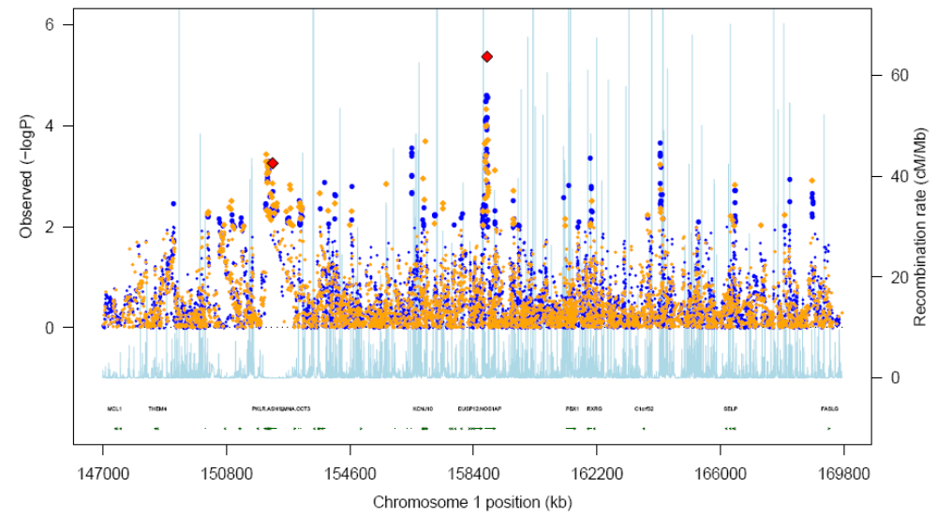
Supplementary Figure 1. 7-way meta-analysis of single-point T2D associations within the 1q region.

This plot shows the “7-way” (European, East Asian descent and Pima populations) meta-analysis using the additive model (Cochran-Armitage trend test). Directly typed SNPs are shown in orange, imputed SNPs in blue. The pale blue track (and secondary y-axis) represents recombination rates (for HapMap CEU) across the region. Red diamonds represent the strongest association additive model p-value in the two regions taken forward for replication. Only a small subset of genes within the region is denoted on the gene-track.

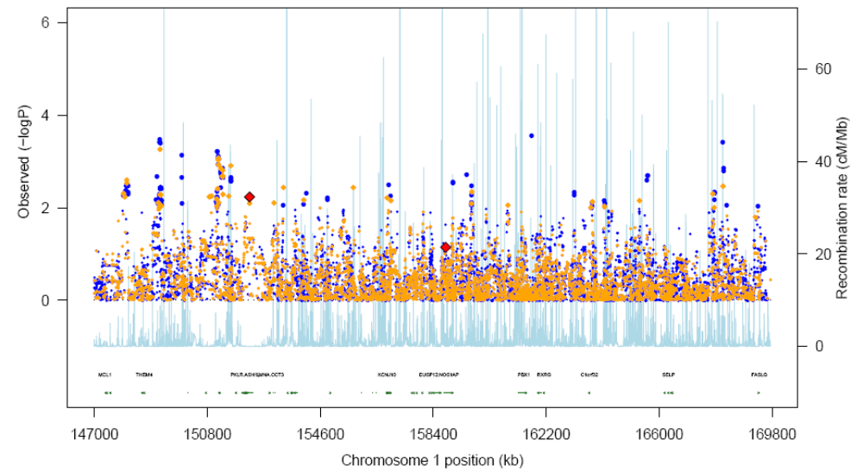
Supplementary Figure 2 (A). Amish population-specific single-point T2D associations within the 1q region.

This plot shows the results for Amish sample for the additive model (Cochran-Armitage trend test). Directly typed SNPs are shown in orange, imputed SNPs in blue. The pale blue track (and secondary y-axis) represents recombination rates (for HapMap CEU) across the region. Red diamonds represent the strongest association additive model p-value in the two regions for the SNPs taken forward for replication. Only a small subset of genes within the region is denoted on the gene-track.

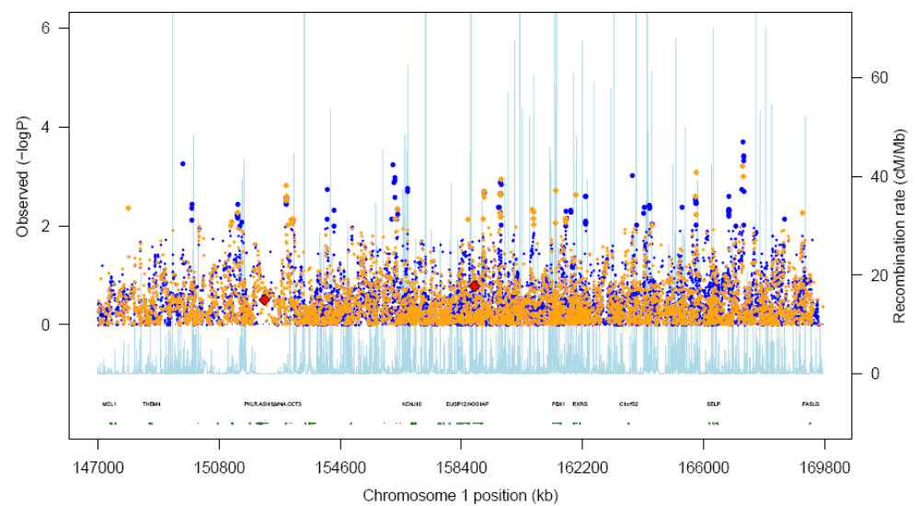
Supplementary Figure 2 (B). French population-specific single-point T2D associations within the 1q region.

This plot shows the results for French sample for the additive model (Cochran-Armitage trend test). Directly typed SNPs are shown in orange, imputed SNPs in blue. The pale blue track (and secondary y-axis) represents recombination rates (for HapMap CEU) across the region. Red diamonds represent the strongest association additive model p-value in the two regions for the SNPs taken forward for replication. Only a small subset of genes within the region is denoted on the gene-track.

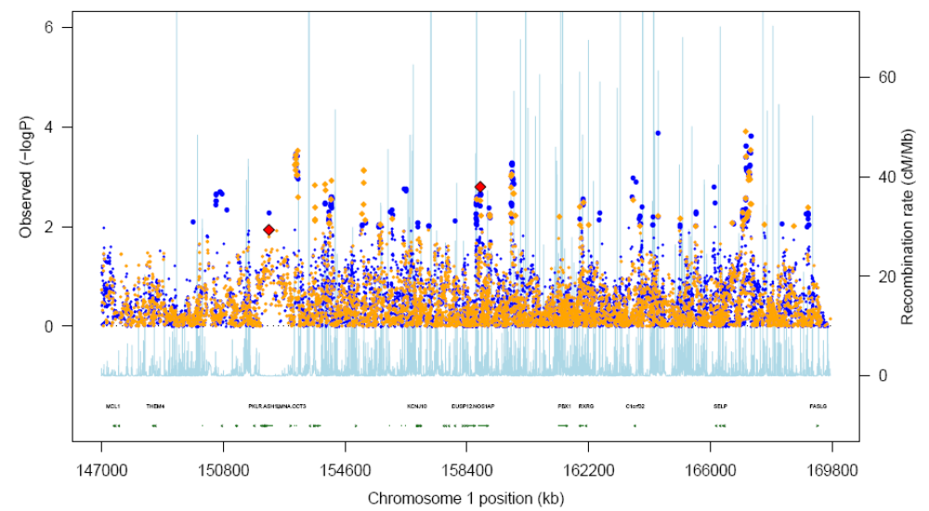
Supplementary Figure 2 (C). UK population-specific single -point T2D associations within the 1q region.

This plot shows the results for UK sample for the additive model (Cochran-Armitage trend test). Directly typed SNPs are shown in orange, imputed SNPs in blue. The pale blue track (and secondary y-axis) represents recombination rates (for HapMap CEU) across the region. Red diamonds represent the strongest association additive model p-value in the two regions for the SNPs taken forward for replication. Only a small subset of genes within the region is denoted on the gene-track.

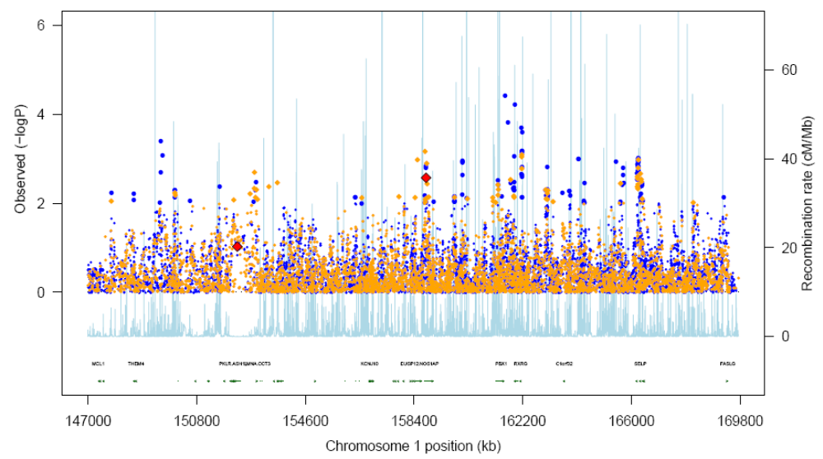
Supplementary Figure 2 (D). Utah population-specific single -point T2D associations within the 1q region.

This plot shows the results for Utah sample for the additive model (Cochran-Armitage trend test). Directly typed SNPs are shown in orange, imputed SNPs in blue. The pale blue track (and secondary y-axis) represents recombination rates (for HapMap CEU) across the region. Red diamonds represent the strongest association additive model p-value in the two regions for the SNPs taken forward for replication. Only a small subset of genes within the region is denoted on the gene-track.

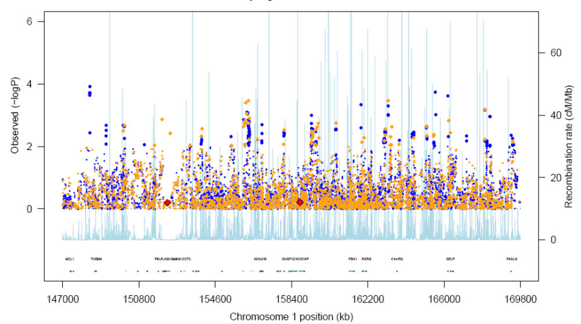
Supplementary Figure 2 (E). Pima population-specific single -point T2D associations within the 1q region.

This plot shows the results for Pima sample for the additive model (Cochran-Armitage trend test). Directly typed SNPs are shown in orange, imputed SNPs in blue. The pale blue track (and secondary y-axis) represents recombination rates (for HapMap CEU) across the region. Red diamonds represent the strongest association additive model p-value in the two regions for the SNPs taken forward for replication. Only a small subset of genes within the region is denoted on the gene-track.

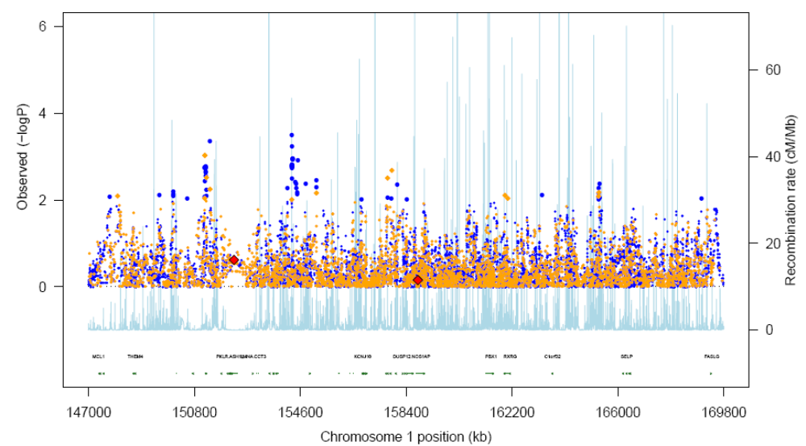
Supplementary Figure 2 (F). Hong Kong population-specific single -point T2D associations within the 1q region.

This plot shows the results for Hong Kong sample for the additive model (Cochran-Armitage trend test). Directly typed SNPs are shown in orange, imputed SNPs in blue. The pale blue track (and secondary y-axis) represents recombination rates (for HapMap CEU) across the region. Red diamonds represent the strongest association additive model p-value in the two regions for the SNPs taken forward for replication. Only a small subset of genes within the region is denoted on the gene-track.

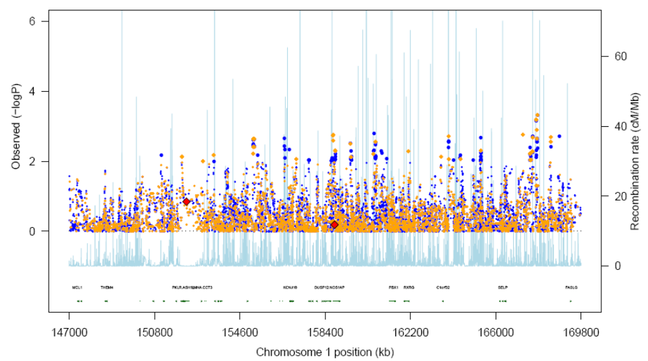
Supplementary Figure 2 (G). Shanghai Population-specific single -point T2D associations within the 1q region.

This plot shows the results for Shanghai sample for the additive model (Cochran-Armitage trend test). Directly typed SNPs are shown in orange, imputed SNPs in blue. The pale blue track (and secondary y-axis) represents recombination rates (for HapMap CEU) across the region. Red diamonds represent the strongest association additive model p-value in the two regions for the SNPs taken forward for replication. Only a small subset of genes within the region is denoted on the gene-track.

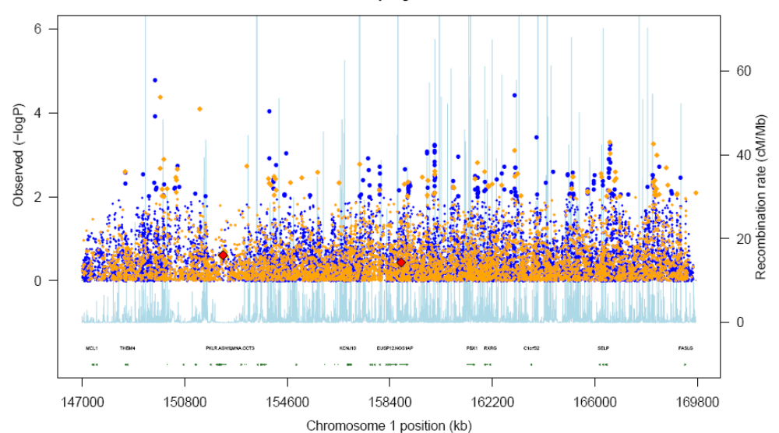
Supplementary Figure 2 (H). African population-specific single -point T2D associations within the 1q region.

This plot shows the results for African American sample for the additive model (Cochran-Armitage trend test). Directly typed SNPs are shown in orange, imputed SNPs in blue. The pale blue track (and secondary y-axis) represents recombination rates (for HapMap CEU) across the region. Red diamonds represent the strongest association additive model p-value in the two regions for the SNPs taken forward for replication. Only a small subset of genes within the region is denoted on the gene-track.
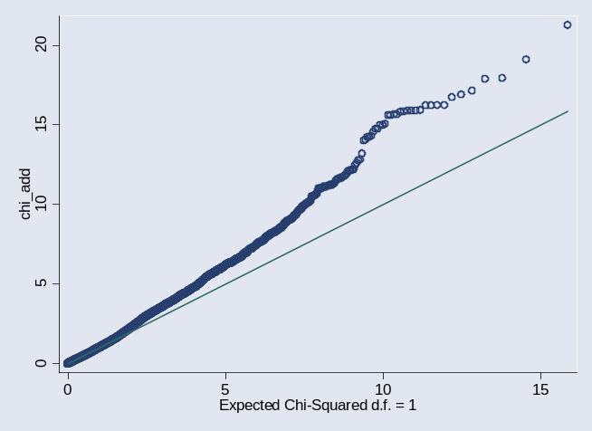
A
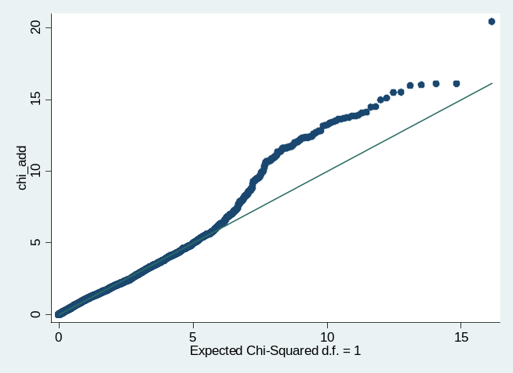
B

Supplementary Figure 3. Q-Q plots for the meta-analysis (chi-square distribution based on p-values) of T2D association within the 1q region across (A) 4 European-origin populations, (B) 7 populations of European or East Asian origin.

The p values for the corresponding chi-square test statistics are plotted as a function of the expected chi-square distribution for directly genotyped and imputed SNPs. Amish and Pima population specific association tests are corrected using genomic control method.

rs7538490
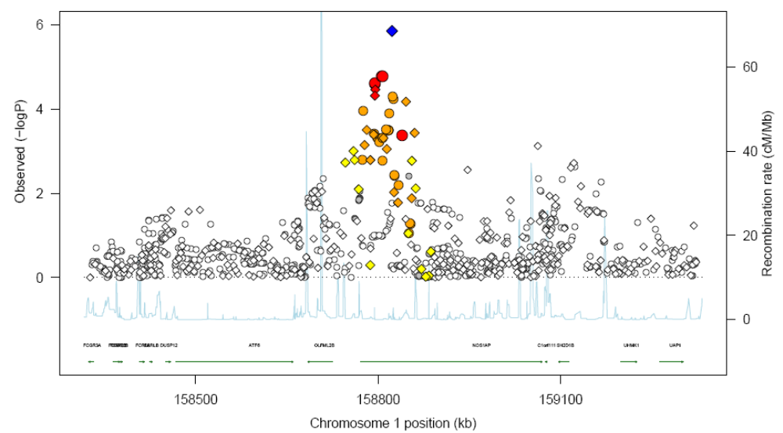

Supplementary Figure 4 (A). Single-point T2D associations within the NOS1AP region in 4-way meta-analysis.

This plot shows the “4-way” (European populations) meta-analysis using the additive model (Cochran-Armitage trend test). Directly typed SNPs are shown with diamonds, imputed SNPs with circles. The pale blue track (and secondary y-axis) represents recombination rates (for HapMap CEU) across the region to reflect the local LD structure. The blue diamond indicates the most associated SNP. SNPs are coloured according to linkage disequilibrium (LD), red r² > 0.8, orange r² >= 0.5 and r² < 0.8, yellow r² >= 0.2 and r² < 0.5, grey r² < 0.2, white no LD (r²=0) to SNP rs75384990. Gene annotations were taken from the University of California-Santa Cruz genome browser.

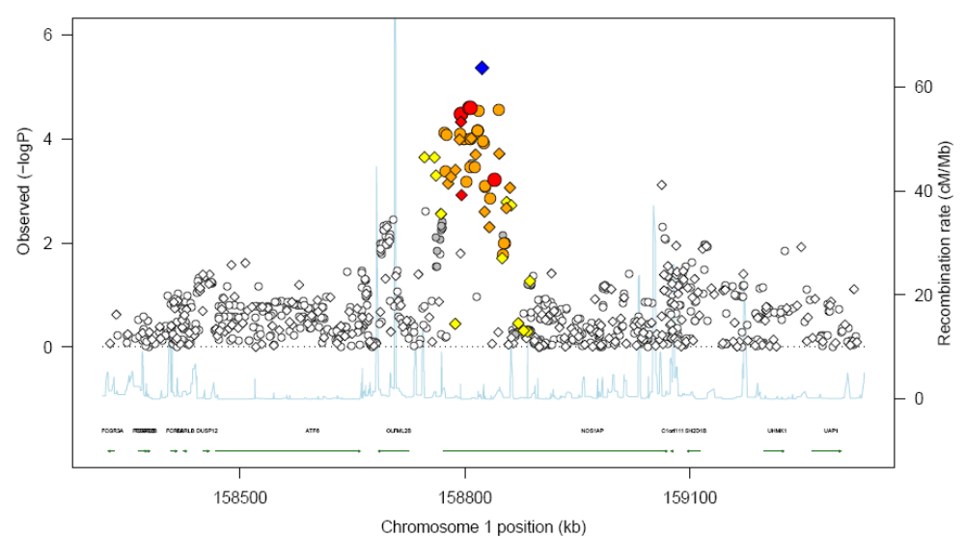
Supplementary Figure 4 (B). Single-point T2D associations within the NOS1AP region in 7-way meta-analysis.
rs7538490

This plot shows the “7-way” (European, East Asian descent and Pima populations) meta-analysis using the additive model (Cochran-Armitage trend test). Directly typed SNPs are shown with diamonds, imputed SNPs with circles. The pale blue track (and secondary y-axis) represents recombination rates (for HapMap CEU) across the region to reflect the local LD structure. The blue diamond indicates the most associated SNP. SNPs are coloured according to linkage disequilibrium (LD), red r² > 0.8, orange r² >= 0.5 and r² < 0.8, yellow r² >= 0.2 and r² < 0.5, grey r² < 0.2, white no LD (r²=0) to SNP rs75384990. Gene annotations were taken from the University of California-Santa Cruz genome browser.

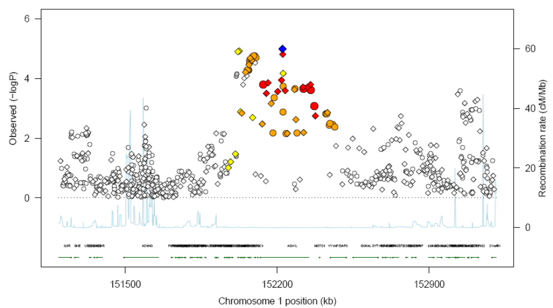
Supplementary Figure 5 (A). Single-point T2D associations within the PKLR/ASH1L region in 4-way meta-analysis.
rs11264371

This plot shows the “4-way” (European populations) meta-analysis using the dominant model (Cochran-Armitage trend test). Directly typed SNPs are shown with diamonds, imputed SNPs with circles. The pale blue track (and secondary y-axis) represents recombination rates (for HapMap CEU) across the region to reflect the local LD structure. The blue diamond indicates the most associated SNP. SNPs are coloured according to linkage disequilibrium (LD), red r² > 0.8, orange r² >= 0.5 and r² < 0.8, yellow r² >= 0.2 and r² < 0.5, grey r² < 0.2, white no LD (r²=0) to rs11264371. Gene annotations were taken from the University of California-Santa Cruz genome browser.

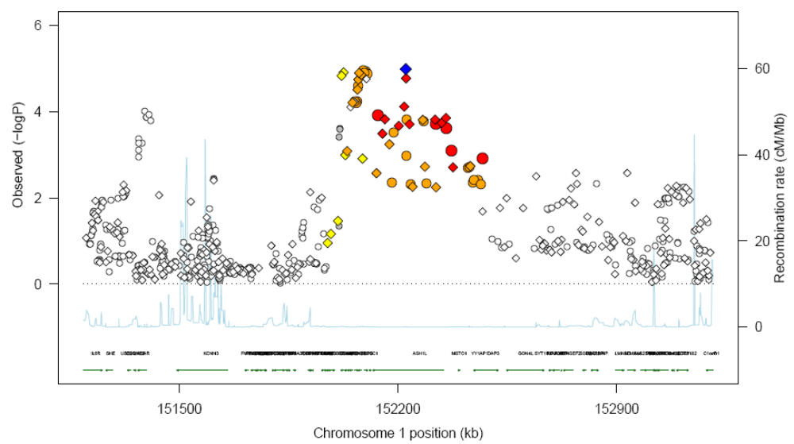
rs11264371
Supplementary Figure 5 (B). Single-point T2D associations within the PKLR/ASH1L region in 7-way meta-analysis.

This plot shows the “7-way” (European, East Asian descent and Pima populations) meta-analysis using the additive model (Cochran-Armitage trend test). Directly typed SNPs are shown with diamonds, imputed SNPs with circles. The pale blue track (and secondary y-axis) represents recombination rates (for HapMap CEU) across the region to reflect the local LD structure. The blue diamond indicates the most associated SNP. SNPs are coloured according to linkage disequilibrium (LD), red r² > 0.8, orange r² >= 0.5 and r² < 0.8, yellow r² >= 0.2 and r² < 0.5, grey r² < 0.2, white no LD (r²=0) to rs11264371. Gene annotations were taken from the University of California-Santa Cruz genome browser.

