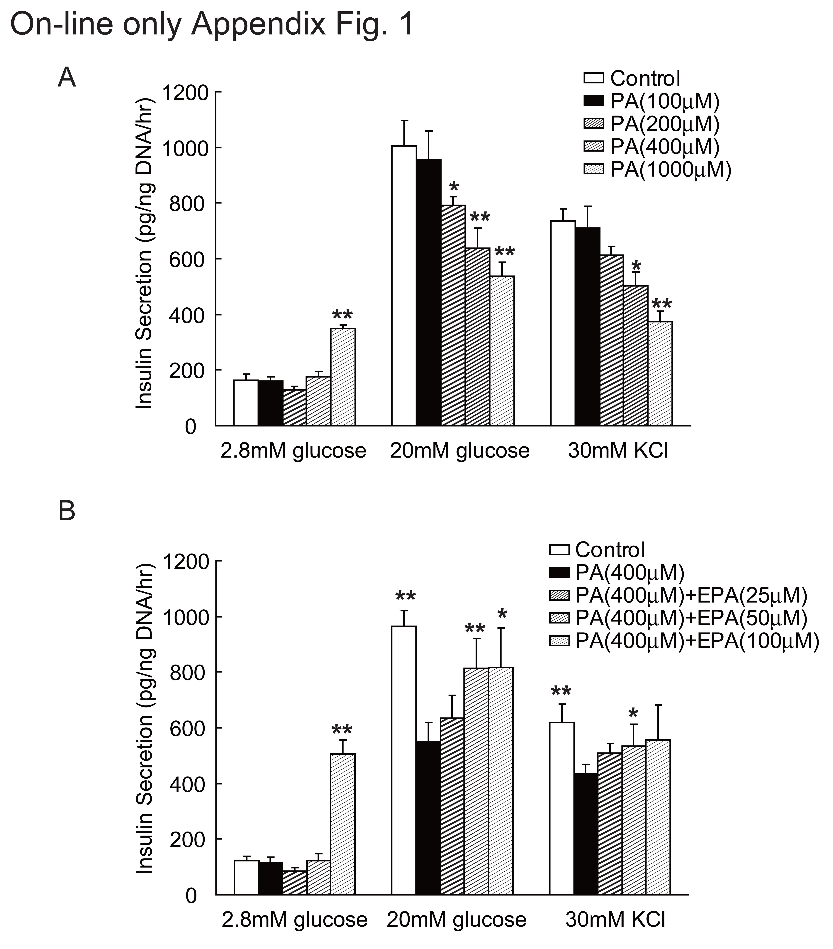

Fig. 1 Dose responses of lipotoxic effects of PA and protective effects of EPA on insulin secretion in murine isolated islets.
Islets were isolated from C57BL/6 mice, and low glucose (2.8 mM), high glucose (20 mM)-and KCl-stimulated insulin secretions from the islets were measured. Insulin secretion from islets incubated without or with indicated dose of PA. Insulin secretion from islets incubated without or with indicated dose of PA or PA-EPA. Three independent experiments were performed using four sets of islets and results are expressed mean ± S.E.M. Statistical analyses were performed using one-way ANOVA followed by Dunnett’s procedure, ** p < 0.01 and * p < 0.05 (A: versus Control group,
B: versus PA group), respectively.

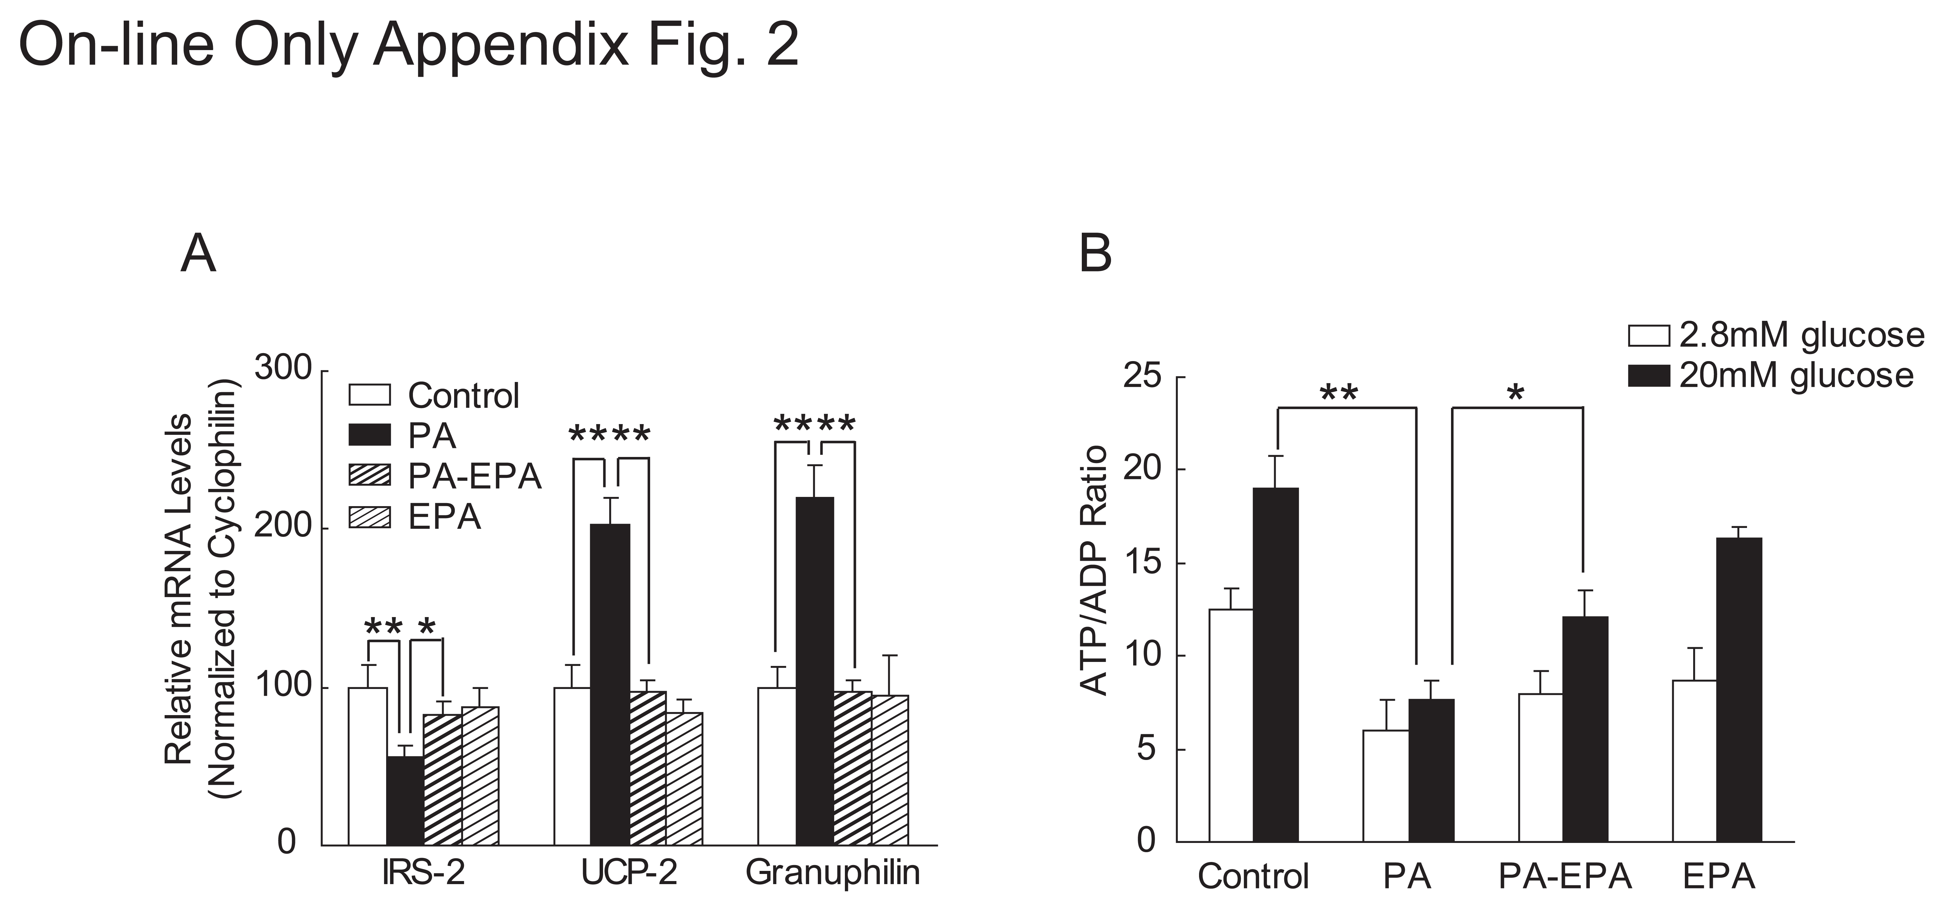

Fig. 2 Gene expression profiles in murine isolated islets treated with PA and PA-EPA.
A) Levels of mRNA of indicated genes in pancreatic islets isolated from C57BL/6 mice without (Control, white bars), or with PA (black bars), PA-EPA (hatched bars), or EPA (regular hatched bars) as determined by real-time PCR. mRNA quantities were calculated as a ratio to the cyclophilin level in the each cDNA sample. Data are shown as the relative expression ratio to control samples. (B) Cellular ATP/ADP ratio of islets incubated without (Control) or, with PA, PA-EPA, or EPA. Three independent experiments were performed using four sets of islets and results are expressed mean ± S.E.M. Statistical analyses were performed using one-way ANOVA followed by Dunnett’s procedure, ** p < 0.01 and * p < 0.05 (versus PA group), respectively.

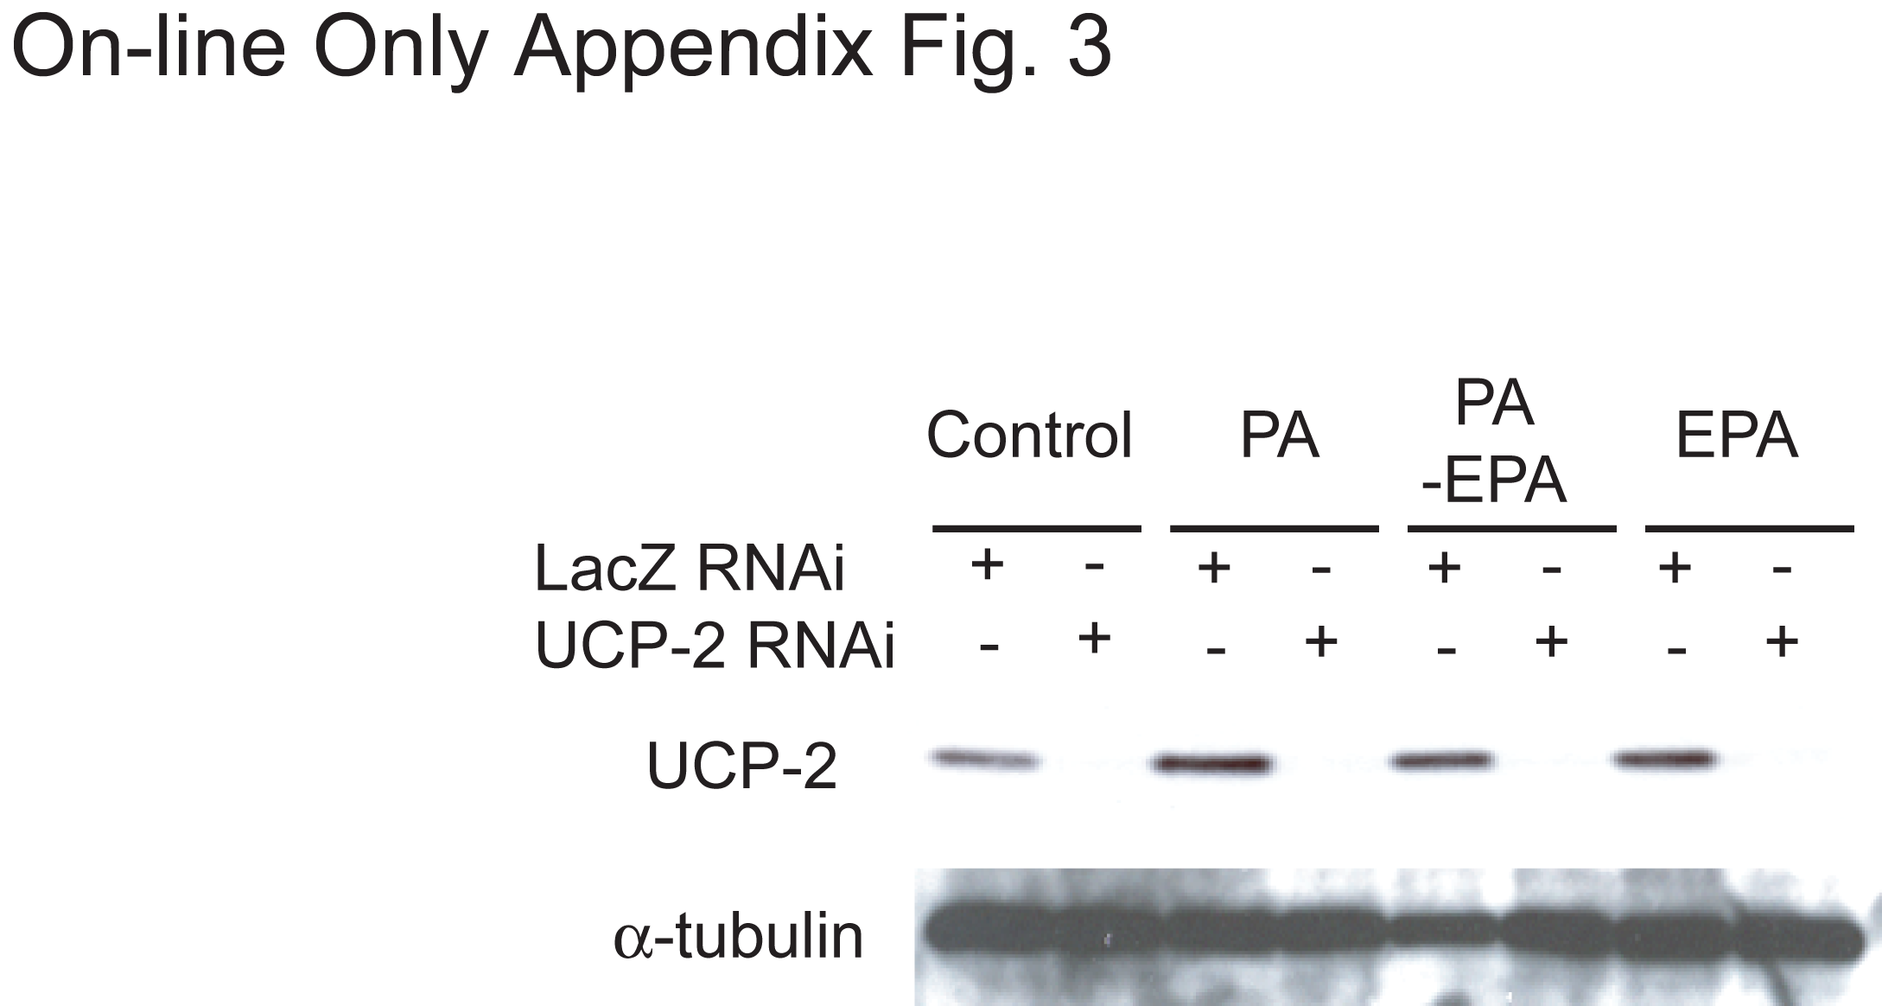

Fig. 3 Protein expression levels by UCP-2 gene silencing on murine isolated islets treated with PA or PA-EPA.

Islets were isolated from C57BL/6 mice and infected (500 M.O.I. respectively) with adenoviral siRNA for LacZ (Ad-LacZ RNAi) or UCP-2 (Ad-UCP-2 RNAi) and cultured without (Control) or with PA, PA-EPA, or EPA for 48 hr. Amount of UCP-2 protein was estimated by immunoblot analysis and α−tubulin protein was used as a loading control.

Fig. 4 Histological analysis of pancreatic islets from mice in Palmitate-rich-diet study and in KK-Ay mice study.
C57BL/6 mice in PA(palmitate)-rich-diet study were fed Control diet, Tripalmitin (20% Tripalmitin), and Tripalmitin + EPA-E (20% Tripalmitin supplemented with 5% EPA) for 28 days (A). KK-Ay mice were received administration of vehicle or EPA-E at a dose of 1 g/kg/day for 28days (B). In both studies, isolated pancreas from mice were fixed in 10% formalin–PBS and embedded in paraffin were sectioned at 8 µm, followed by staining with hematoxylin-eosin. The areas of islets were measured by numbers of pixels using the Adobe Photoshop software package (Adobe Systems, San José, CA) in Palmitate rich-diet study and by using winRooF imaging software (Mitani Corporation, Tokyo, Japan) in KK-Ay mice study, respectively. Islet area from each mouse was calculated as the ratio of total islets areas to pancreatic areas. Islets areas are expressed mean ± S.E.M for 3-5 mice in both studies.

