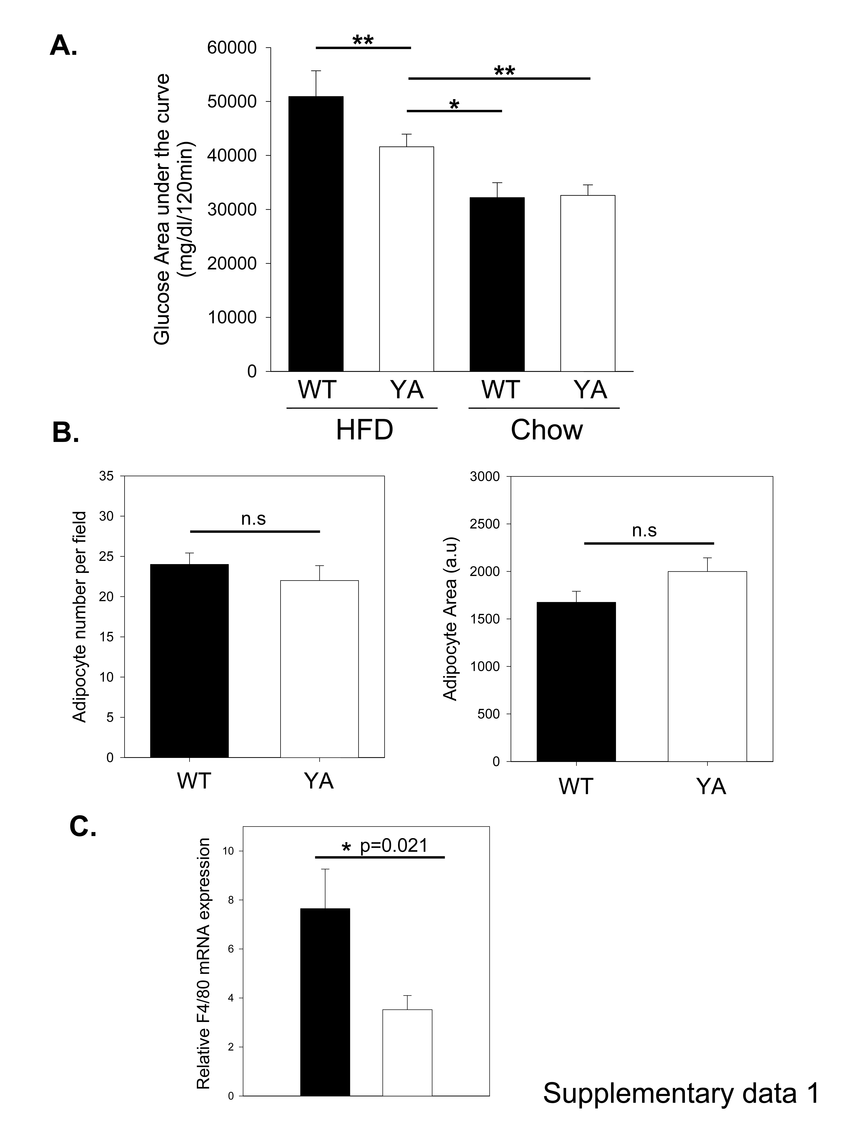
A. α4(Y991A) mutation protects mice against the development of HFD-induced glucose intolerance. In vivo glucose homeostasis was assessed by glucose tolerance testing (GTT) in WT and α4(Y991A) mice on high fat diet (HFD) and normal chow (CHOW). Data from Fig. 1A are represented as total area-under-the-curve (AUC) as for insulin levels (Fig. 1B). B. Comparison of adipocyte cell size and cell number in WT and α4(Y991A) mice. H&E images of white adipose tissue isolated from WT and α4(Y991A) were used to measure adipocyte cell size and cell number (ImageJ software, NIH freeware). There was no statistical difference between genotype. The results shown are mean ±SEM. Sections of 3 mice per group and 5 different tissue areas per mouse were analyzed. n.s not significant. C. Reduction in F4/80 mRNA in WAT from fat-fed α4(Y991A) compared to WT mice. Levels of F4/80 mRNA were determined in vivo in epididymal white adipose tissue (WAT) from WT and α4(Y991A) mice by using real-time RT-PCR. The data are normalized to the expression of V-ATPase. Values are mean ± SEM. p value is also indicated.

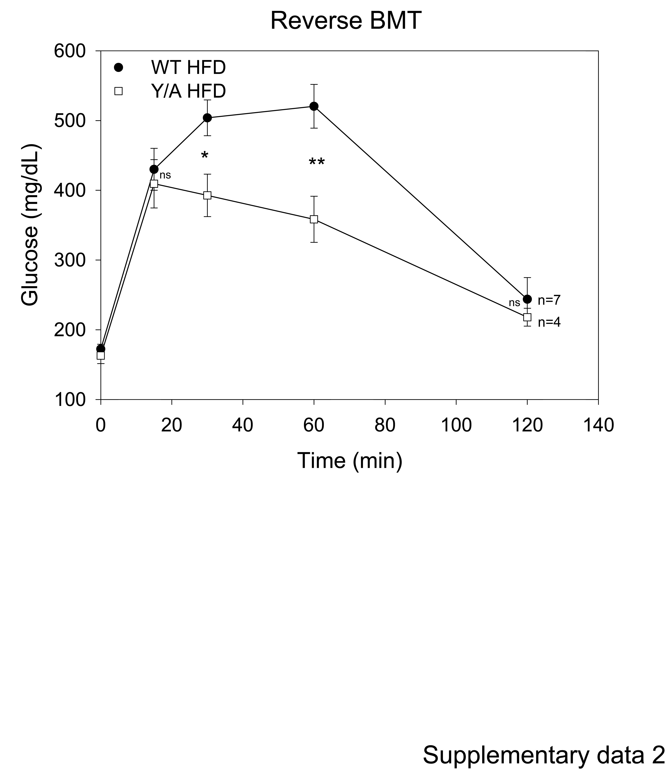

WT bone marrow forces the development of HFD-induced glucose intolerance in α4(Y991A) mice. In vivo glucose homeostasis was assessed by glucose tolerance testing (GTT) in fat-fed α4(Y991A) animals receiving either WT (closed circles) or α4(Y991A) (open squares) bone marrow on high fat diet. The results shown are mean ±SEM for each time point. Number (n) of mice used in this study is also indicated. *p < 0.05; **p < 0.01, ns. not significant.
Supplementary methods
Glucose and insulin tolerance test. For glucose and insulin tolerance tests, animals were fasted 5 h and a basal blood sample was taken. Animals were injected intra-peritoneally with 200 µl glucose (1 g/kg, 50% Dextrose solution FLTP additive-Hospira) or insulin (0.75 U/kg for chow diet and 0.85 U/kg for HFD; Novolin R, Novo-Nordisk, Copenhagen). Blood samples were taken at 15, 30, 45, 60, 90, and 120 min or 10, 20, 30, 45, 60, 90, 120 min; respectively for the determination of blood glucose concentration.
RNA isolation and RT-PCR. Total RNA was isolated from WAT using RNeasy Lipid Tissue Kit (Qiagen). For real-time PCR, cDNA was prepared from 1 µg of total RNA (Perkin–Elmer). Real-time PCR were performed in an iCycler (Bio-Rad) using specific primer sets (see table). mRNA was quantified after normalization to V-ATPase. Separate control experiments demonstrated that the efficiencies of target and reference amplification were equal. PCR specificity was verified by melt-curve analysis of the final products directly in the iCycler and by gel electrophoresis.

Gene | Primers
MCP-1 | Forward: AGCACCAGCCAACTCTCAC  Reverse: TCTGGACCCATTCCTTCTTG
IL-6 | Forward: GACAACCACGGCCTTCCCTA  Reverse: GCCTCCGACTTGTGAAGTGGT
TNFα | Forward: GGCAGGTCTACTTTGGAGTCATTGC  Reverse: ACATTCGAGGCTCCAGTGAATTCGG
Leptin | Forward: TGCTGCAGATAGCCAATGAC  Reverse: GAGTAGAGTGAGGCTTCCAGGA
PAI-1 | Forward: TCAGCCCTTGCTTGCCTCAT  Reverse: GCATAGCCAGCACCGAGGA
cyclophilin | Forward: ATCTGCACTGCCAAGACTGA  Reverse: TTTCACCTTCCCAAAGACCA
V-ATPase | Forward: TGATGCCATGTGTCCTATCC  Reverse: CAGCTCTGTGCCGAAAGAGT

