Supplemental Fig. 1. Effects of adiponectin overexpression on plasma TG under fasting and re-feeding condition. Adiponectin was overexpressed in 8w old C57BL/6J male mice by injecting Ad-mAcrp30 virus. Three days after injection, mice were fasted overnight, and then refed with normal chow. Plasma samples were collected after overnight fasting and 1 or 4 hours after refeeding. Plasma TG was measured. n=5, * p<0.05 vs. Ad-GFP-treated mice at fasting state; # p<0.05 vs. Ad-mAcrp30-treated mice at fasting state.

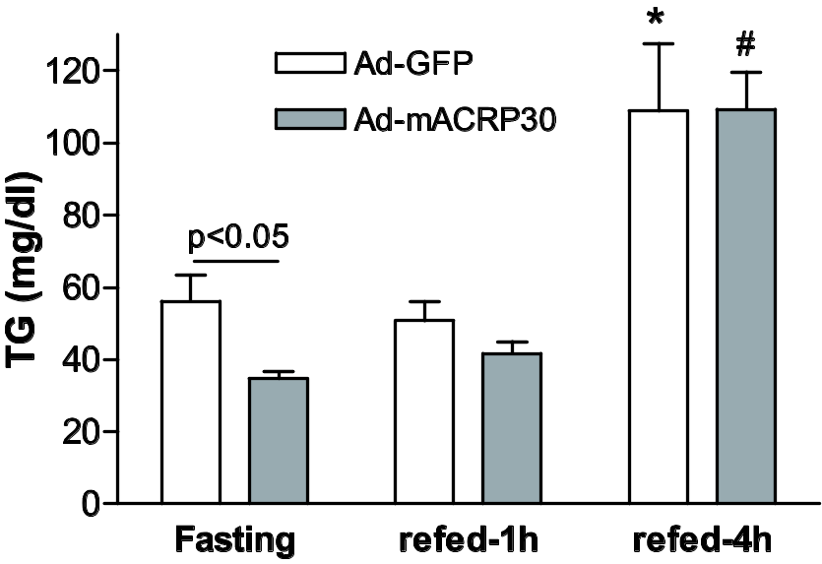

Supplemental Fig. 2. apoB protein distribution in lipoprotein particles. A, C57BL/6J male mice were fasted for 4 hours. Endogenous LPL was inhibited by p-407 injection (detail in the Methods section). apoB protein levels were detected by western blot. n=4, * p<0.05 vs. apoB-100. B, C57BL/6J male mice were treated with adenovirus encoding mouse adiponectin, GFP (3-days) or LPL inhibitor p-407 (4h). Plasma fractions were fractionated by FPLC. Total cholesterol was measured to identify the elution positions of the major lipoprotein classes. ApoB in fractions 12-35 was measured by Western blot. Images are representative of 4 mice in each group.



