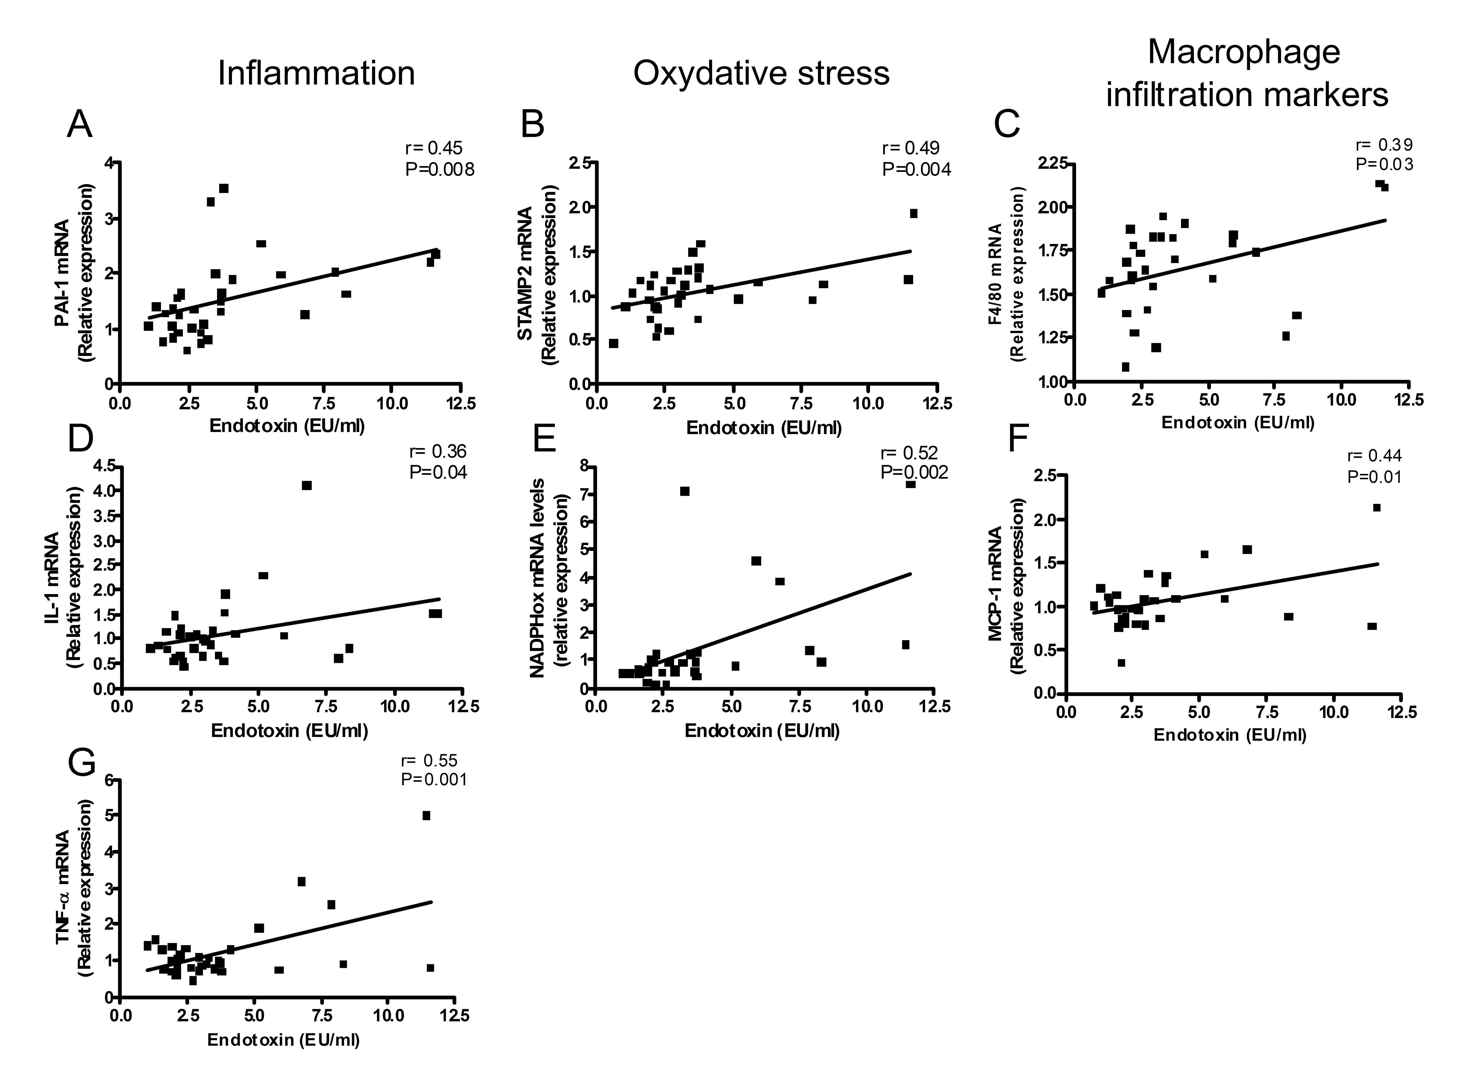 Supplemantal data 1: Metabolic endotoxemia positively correlated with inflammation, oxidative stress and macrophage infiltration markers.
Correlations between plasma endotoxin (LPS, EU/ml) A: PAI-1 mRNA, B :STAMP2 mRNA, C: F4/80 mRNA, D: IL-1 mRNA, E: NADPHox mRNA, F: MCP-1 mRNA, G: TNF-α mRNA concentrations in the visceral adipose depots of normal-diet (CT), normal-diet and antibiotics (CT-Ab), high-fat diet (HF) or high-fat diet and antibiotic fed (HF-Ab) mice for 4 weeks. P<0.05, inset corresponds to Pearson’s r correlation and corresponding P value.

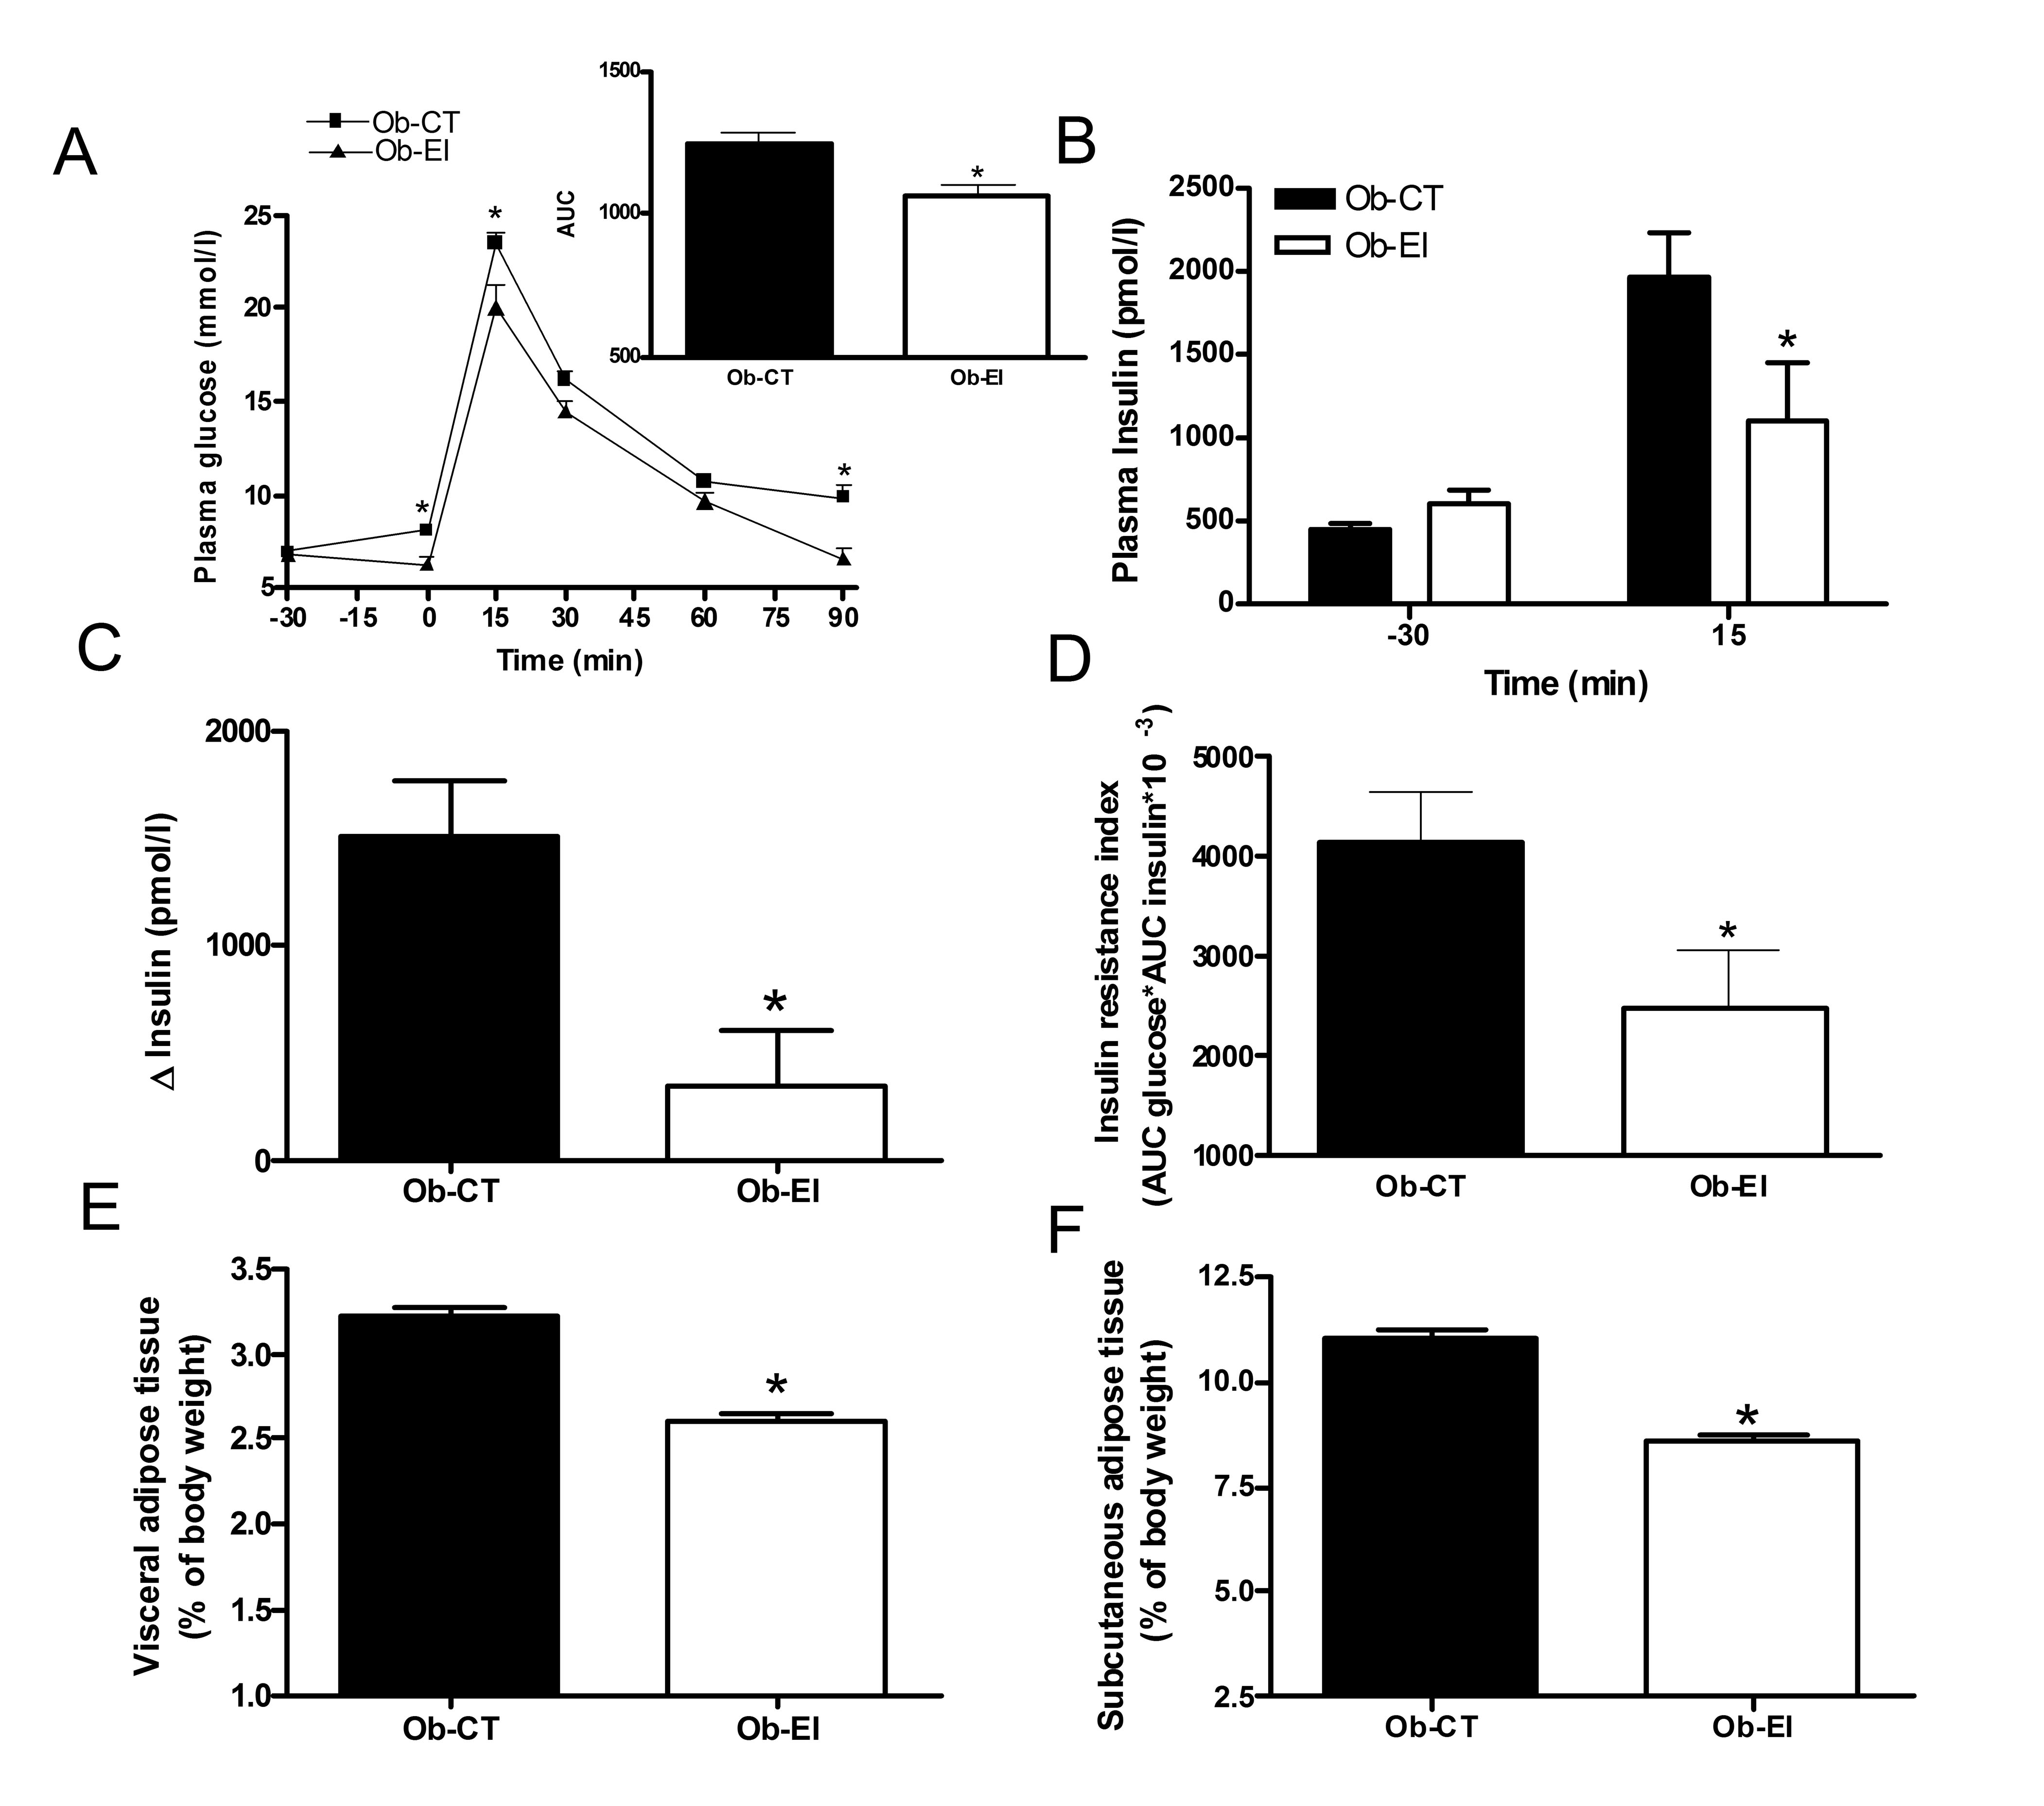
Supplemental data 2: ob/ob mice treated with endotoxin inhibitor (EI: 0.1mg/kg) administered via osmotic mini-pumps for four weeks improved metabolic parameters.
A: Plasma glucose (mmol/l) following an oral glucose load (1g/kg) in ob/ob (Ob), ob/ob treated with an endotoxin inhibitor (polymixin B) (Ob-EI) for 4 weeks, the inset represents the area under curve (AUC) of the same groups. B: Plasma insulin concentration (pmol/l) 30 minutes before (-30) and 15 minutes after (15) oral glucose administration of the same groups. C: Glucose induced-insulin secretion after oral glucose administration. D: Insulin resistance index. E: Visceral adipose tissue weight (% of body weight). F: subcutaneous adipose tissue weight (% of body weight) in the same groups. Data are mean±SE. Data are significantly different P<0.05, according to the t-test statistical analysis.

