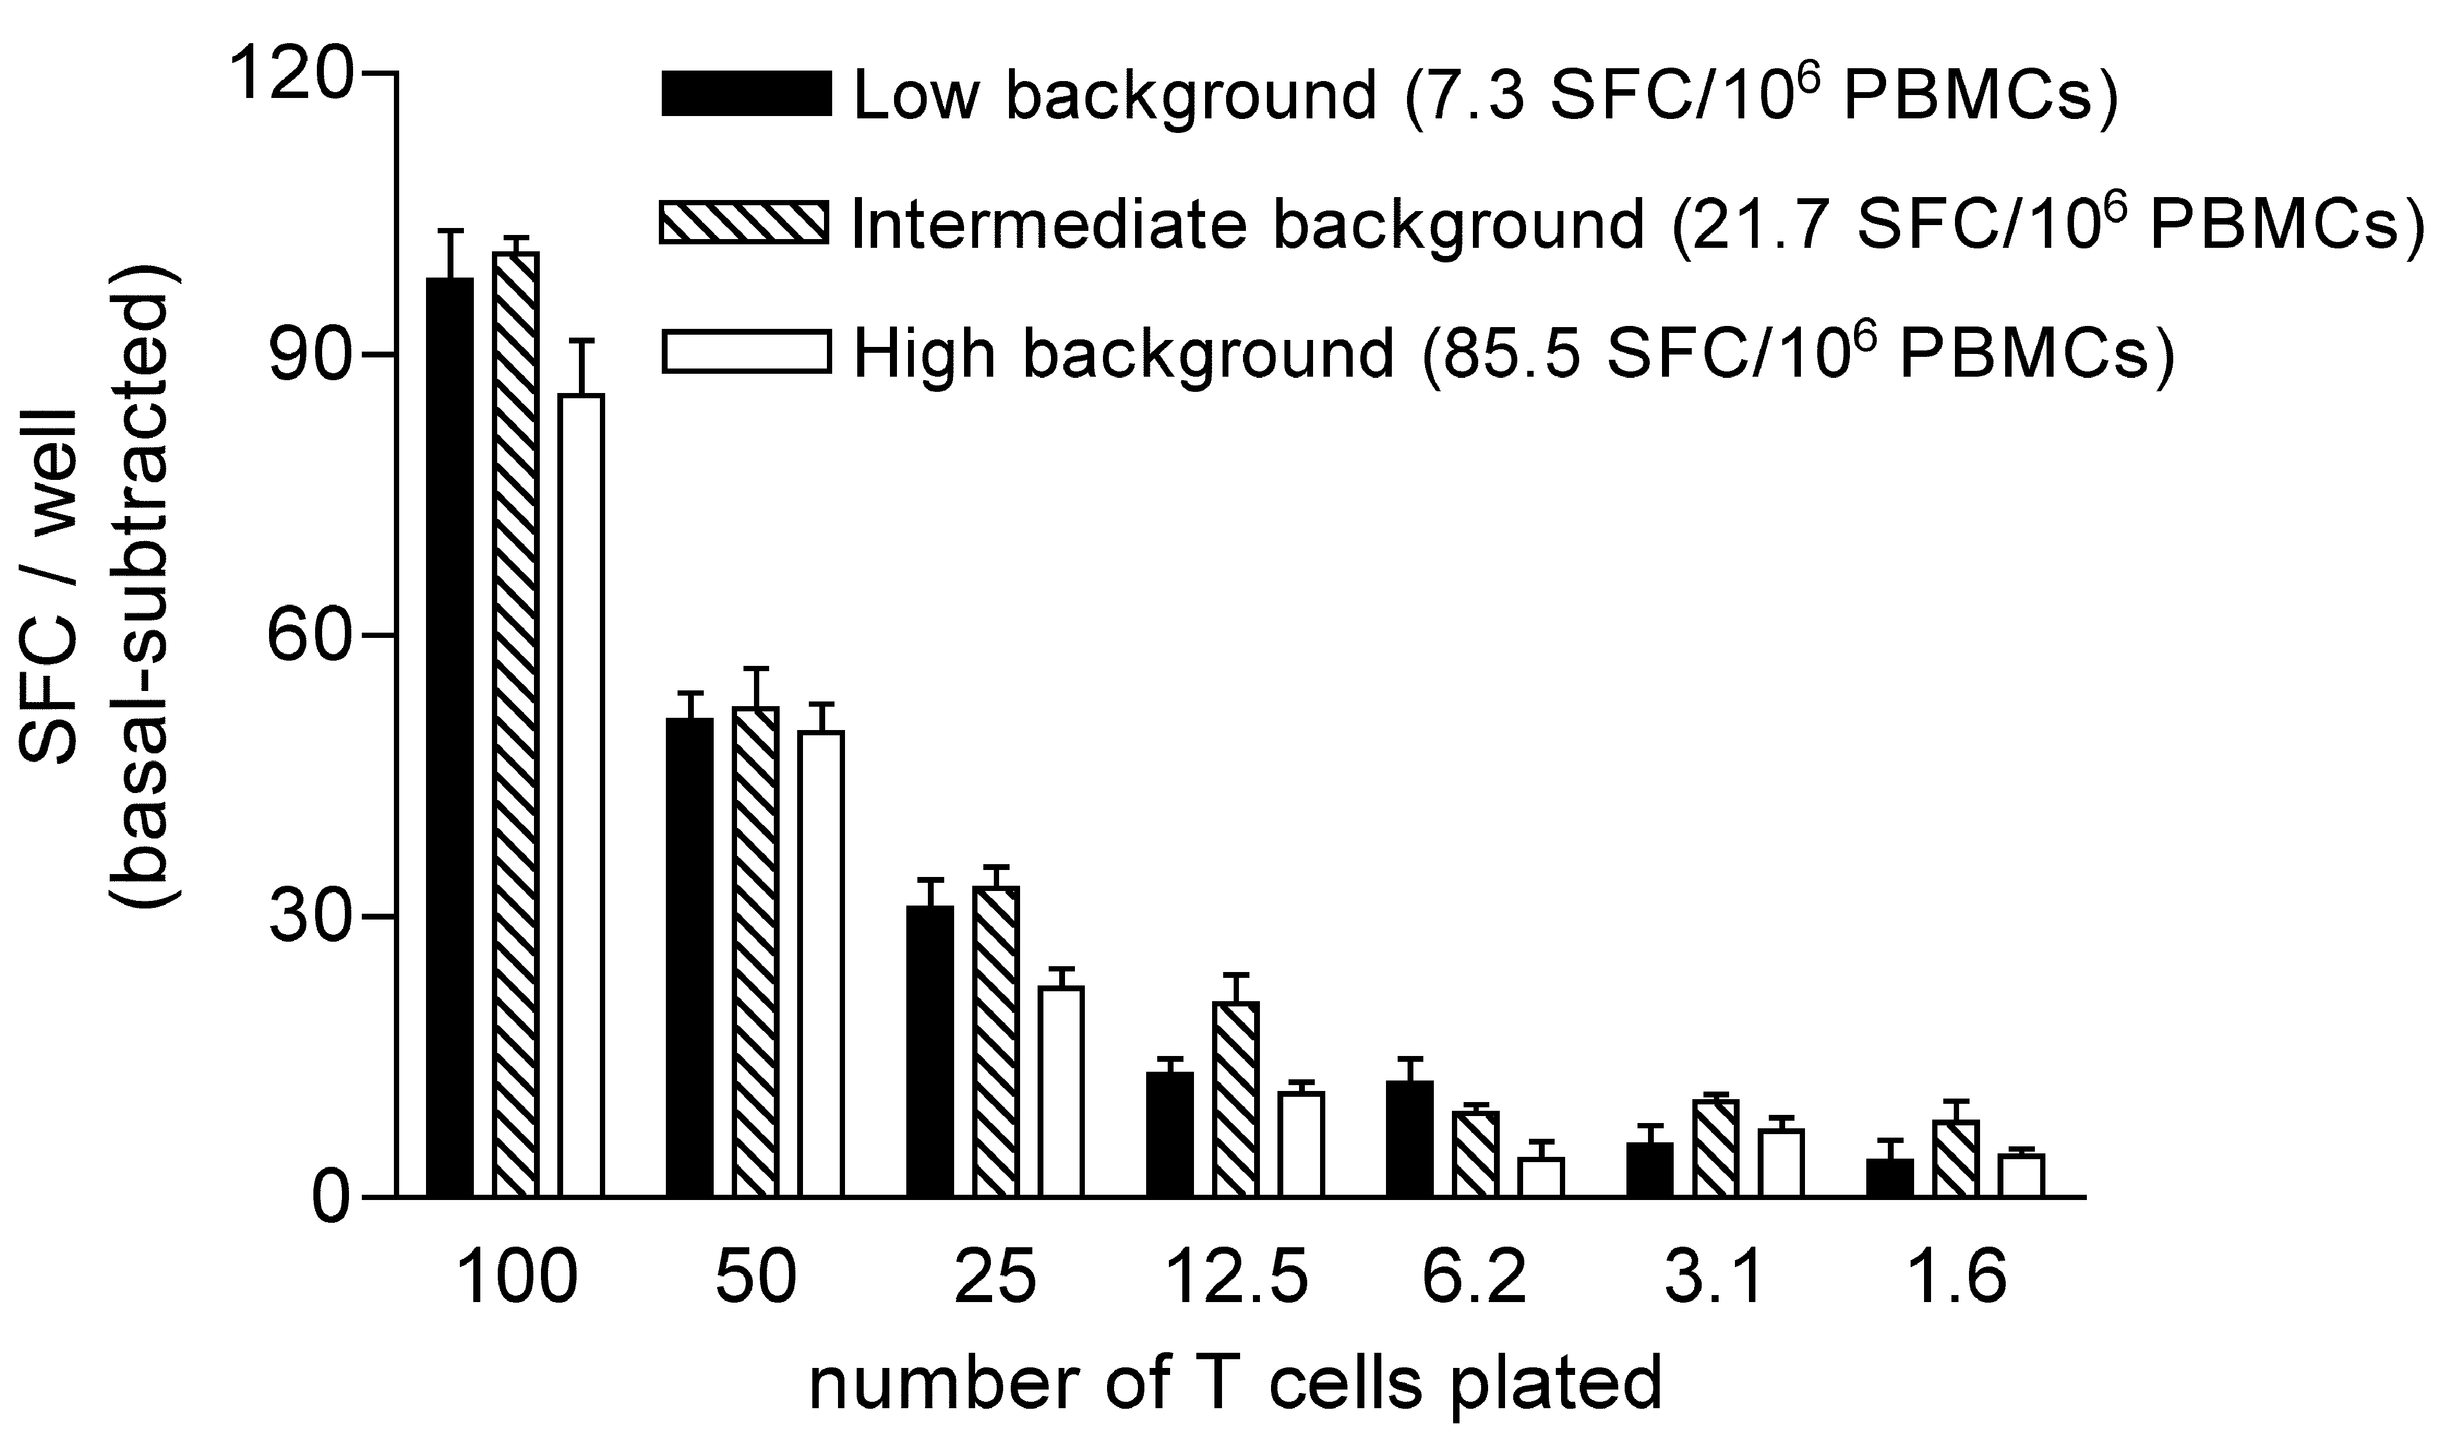FIGURE 1

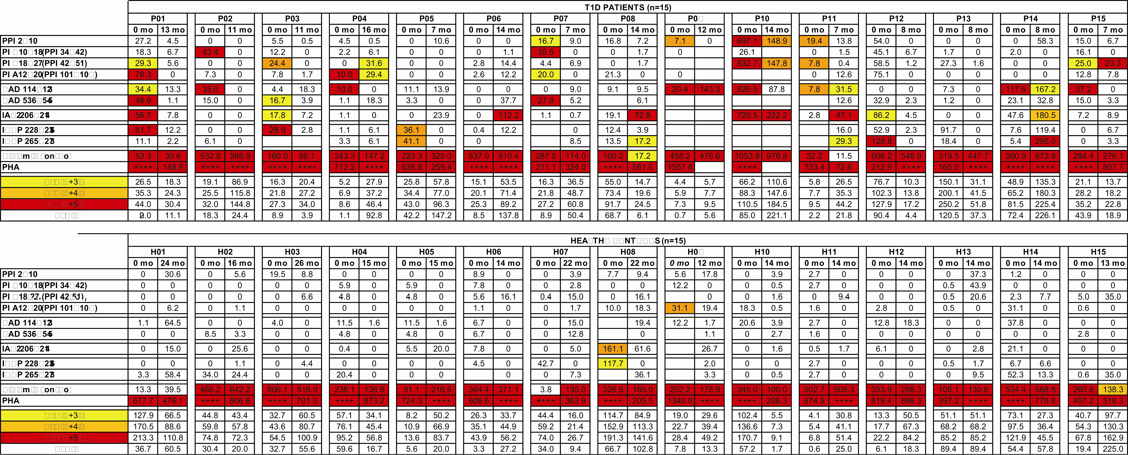

FIGURE 2

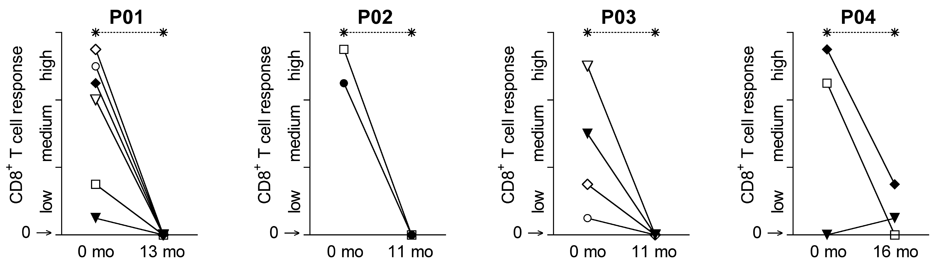FIGURE 3
PART 1
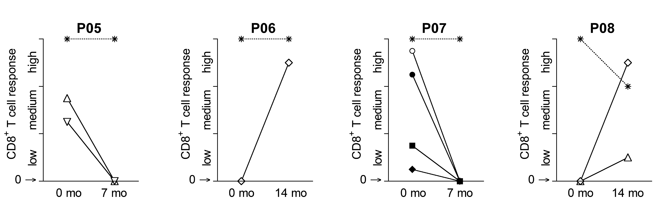
FIGURE 3
PART 2

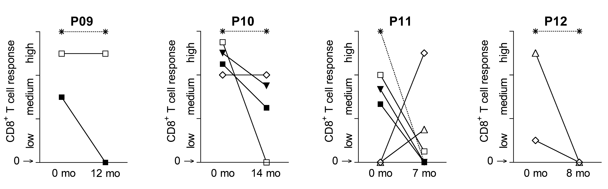

FIGURE 3
PART 3

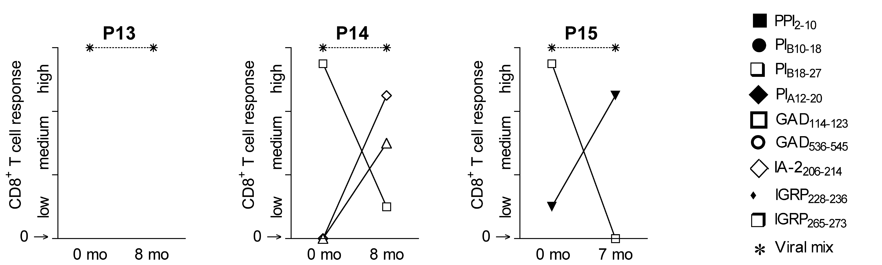

FIGURE 3
PART 4

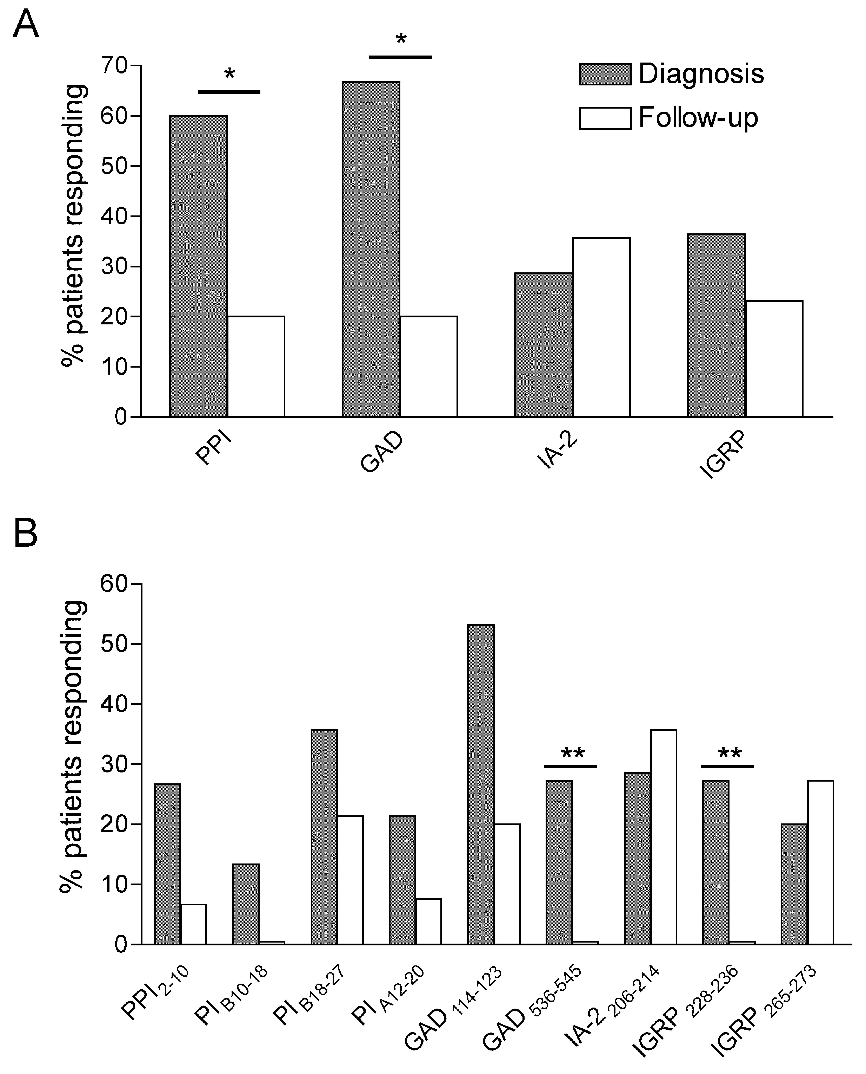

FIGURE 4

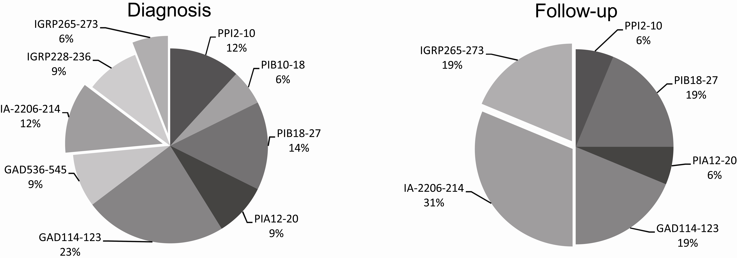

FIGURE 5

