Supplemental Data:
Supplemental Figure 1: CB4 infection accelerates diabetes induction in NOD mice.
A) Diabetes incidence of 10 weeks old NOD mice infected with CB4 (filled squares) or mock-infected with DMEM (open circles). B) Spontaneous incidence of diabetes of uninfected NOD (filled squares) or NODTGFβ mice (open diamonds).

Supplemental Figure 2: Cytokine production in NOD and NODTGFβ mice prior to infection. Cytokine production from A) CD4 T cells and B) CD8 T cells from the spleen of NOD (black bars) and NODTGFβ (white bars) mice was measured ex vivo by intracellular flow cytometry following restimulation with PMA and ionomycin. Data are presented as mean ± s.e.m. and are representative of 4 mice per group from 2 separate experiments.

Supplemental Figure 3: CB4 infection does not significantly increase Tregs in the spleen of NODTGFβ mice. Representative histograms of Foxp3 expression by CD4⁺ T cells in the spleen of NODTGFβ mice 7 days following A) mock-infection with DMEM or infection with B) CB4 or C) CB3. Numbers shown on the histograms represent percentage of Foxp3 positive cells. Isotype controls are represented by shaded grey areas. D) Average percentage of Foxp3⁺ CD4⁺ T cells in the spleen of NODTGFβ mice following mock-infection with DMEM (black bars, n=10) or infection with CB4 (white bars, n=13) or CB3 (grey bars, n=12). Data are presented as mean value ± s.e.m. and are representative of at least 3 separate experiments.

Supplemental Figure 4: Pancreatic expression of TGF-β does not affect T cell activation in the PLN following CB4 infection. Representative histograms of the surface expression of CD69 (A, B) and CD62L (C, D) on CD4+ (A, C) or CD8+ (B, D) T cells from the PLN of either NOD (black lines) or NODTGFβ (grey lines) mice. Data are representative of at least 3 separate experiments.

Supplemental Figure 5: Pancreatic expression of TGF-β does not affect upregulation of costimulatory molecules on dendritic cells following CB4 infection. Representative histogram of A) CD40, B) CD80 and C) CD86 on dendritic cells (CD11c+) from NOD (black line) or NODTGFβ (grey line) mice 7 days PI with CB4. Average mean fluorescence intensity of D) CD40, E) CD80 and F) CD86 on dendritic cells (CD11c⁺) from NOD (black bars) or NODTGFβ (white bars) mice. Data are presented as mean ± s.e.m. and are representative of at least 5 mice per group from at least 2 separate experiments.

Supplemental Figure 6: Costimulatory molecule expression on antigen presenting cells from NODTGFβ mice is similar to NOD mice prior to infection. Average MFI of costimulatory molecule expression on macrophages (CD11b⁺ CD11c⁻, A, B, C) or dendritic cells (CD11c⁺, D, E, F) from NOD (black bars) or NODTGFβ (white bars) mice at day 3 PI. Data are presented as mean value ± s.e.m. and represent at least 2 separate experiments and 5 mice per group.

Supplemental Figure 7: Antigen presenting cells from NODTGFβ mice respond normally to viral infection at early time points. Average MFI of costimulatory molecule expression on macrophages (CD11b⁺ CD11c⁻, A, B, C) or dendritic cells (CD11c⁺, D, E, F) from NOD (black bars) or NODTGFβ (white bars) mice at day 3 PI. Data are presented as mean value ± s.e.m. and represent at least 2 separate experiments and 5 mice per group.
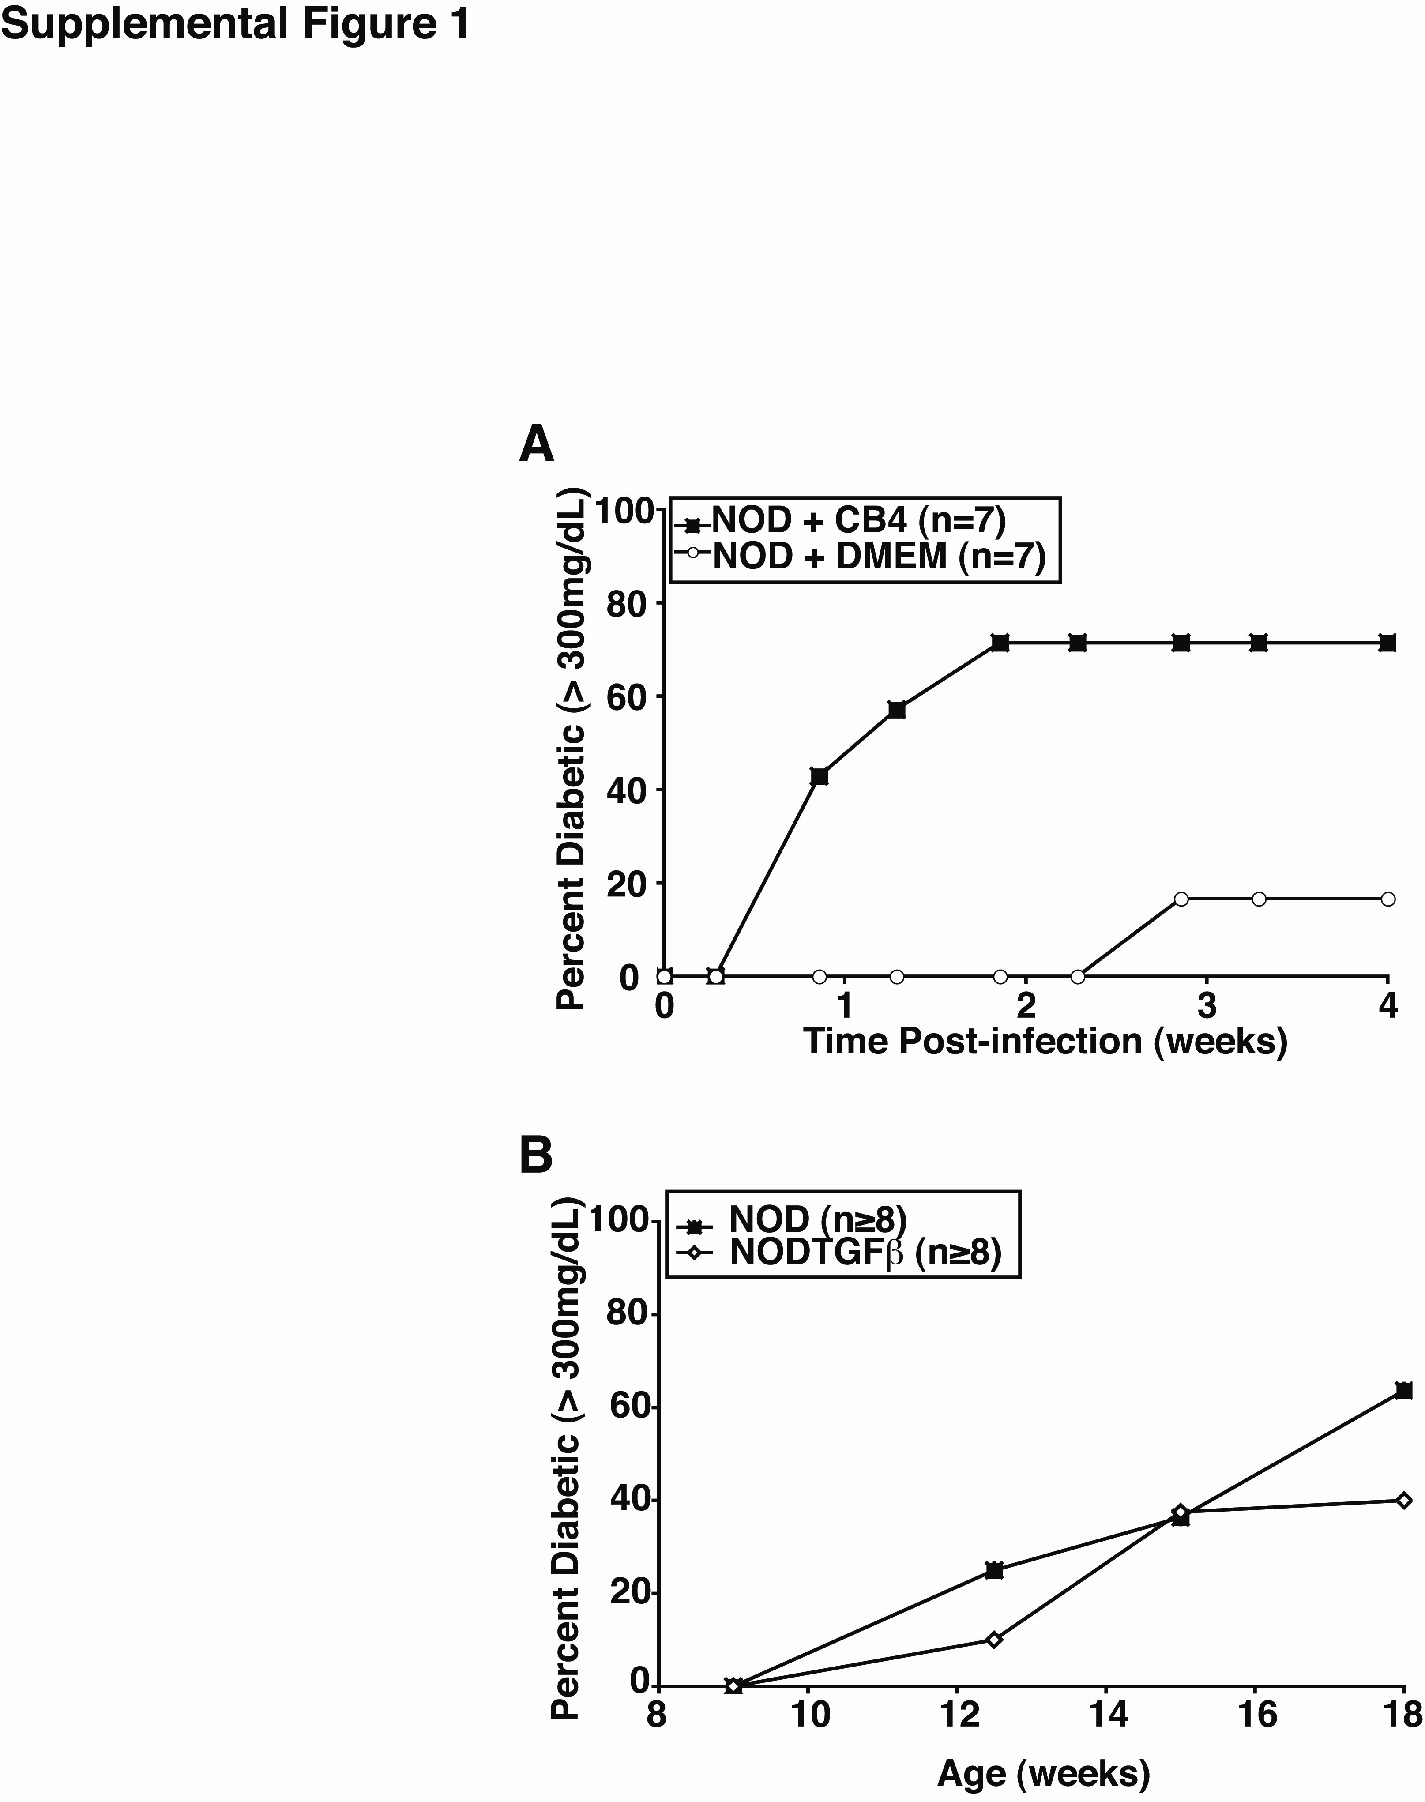
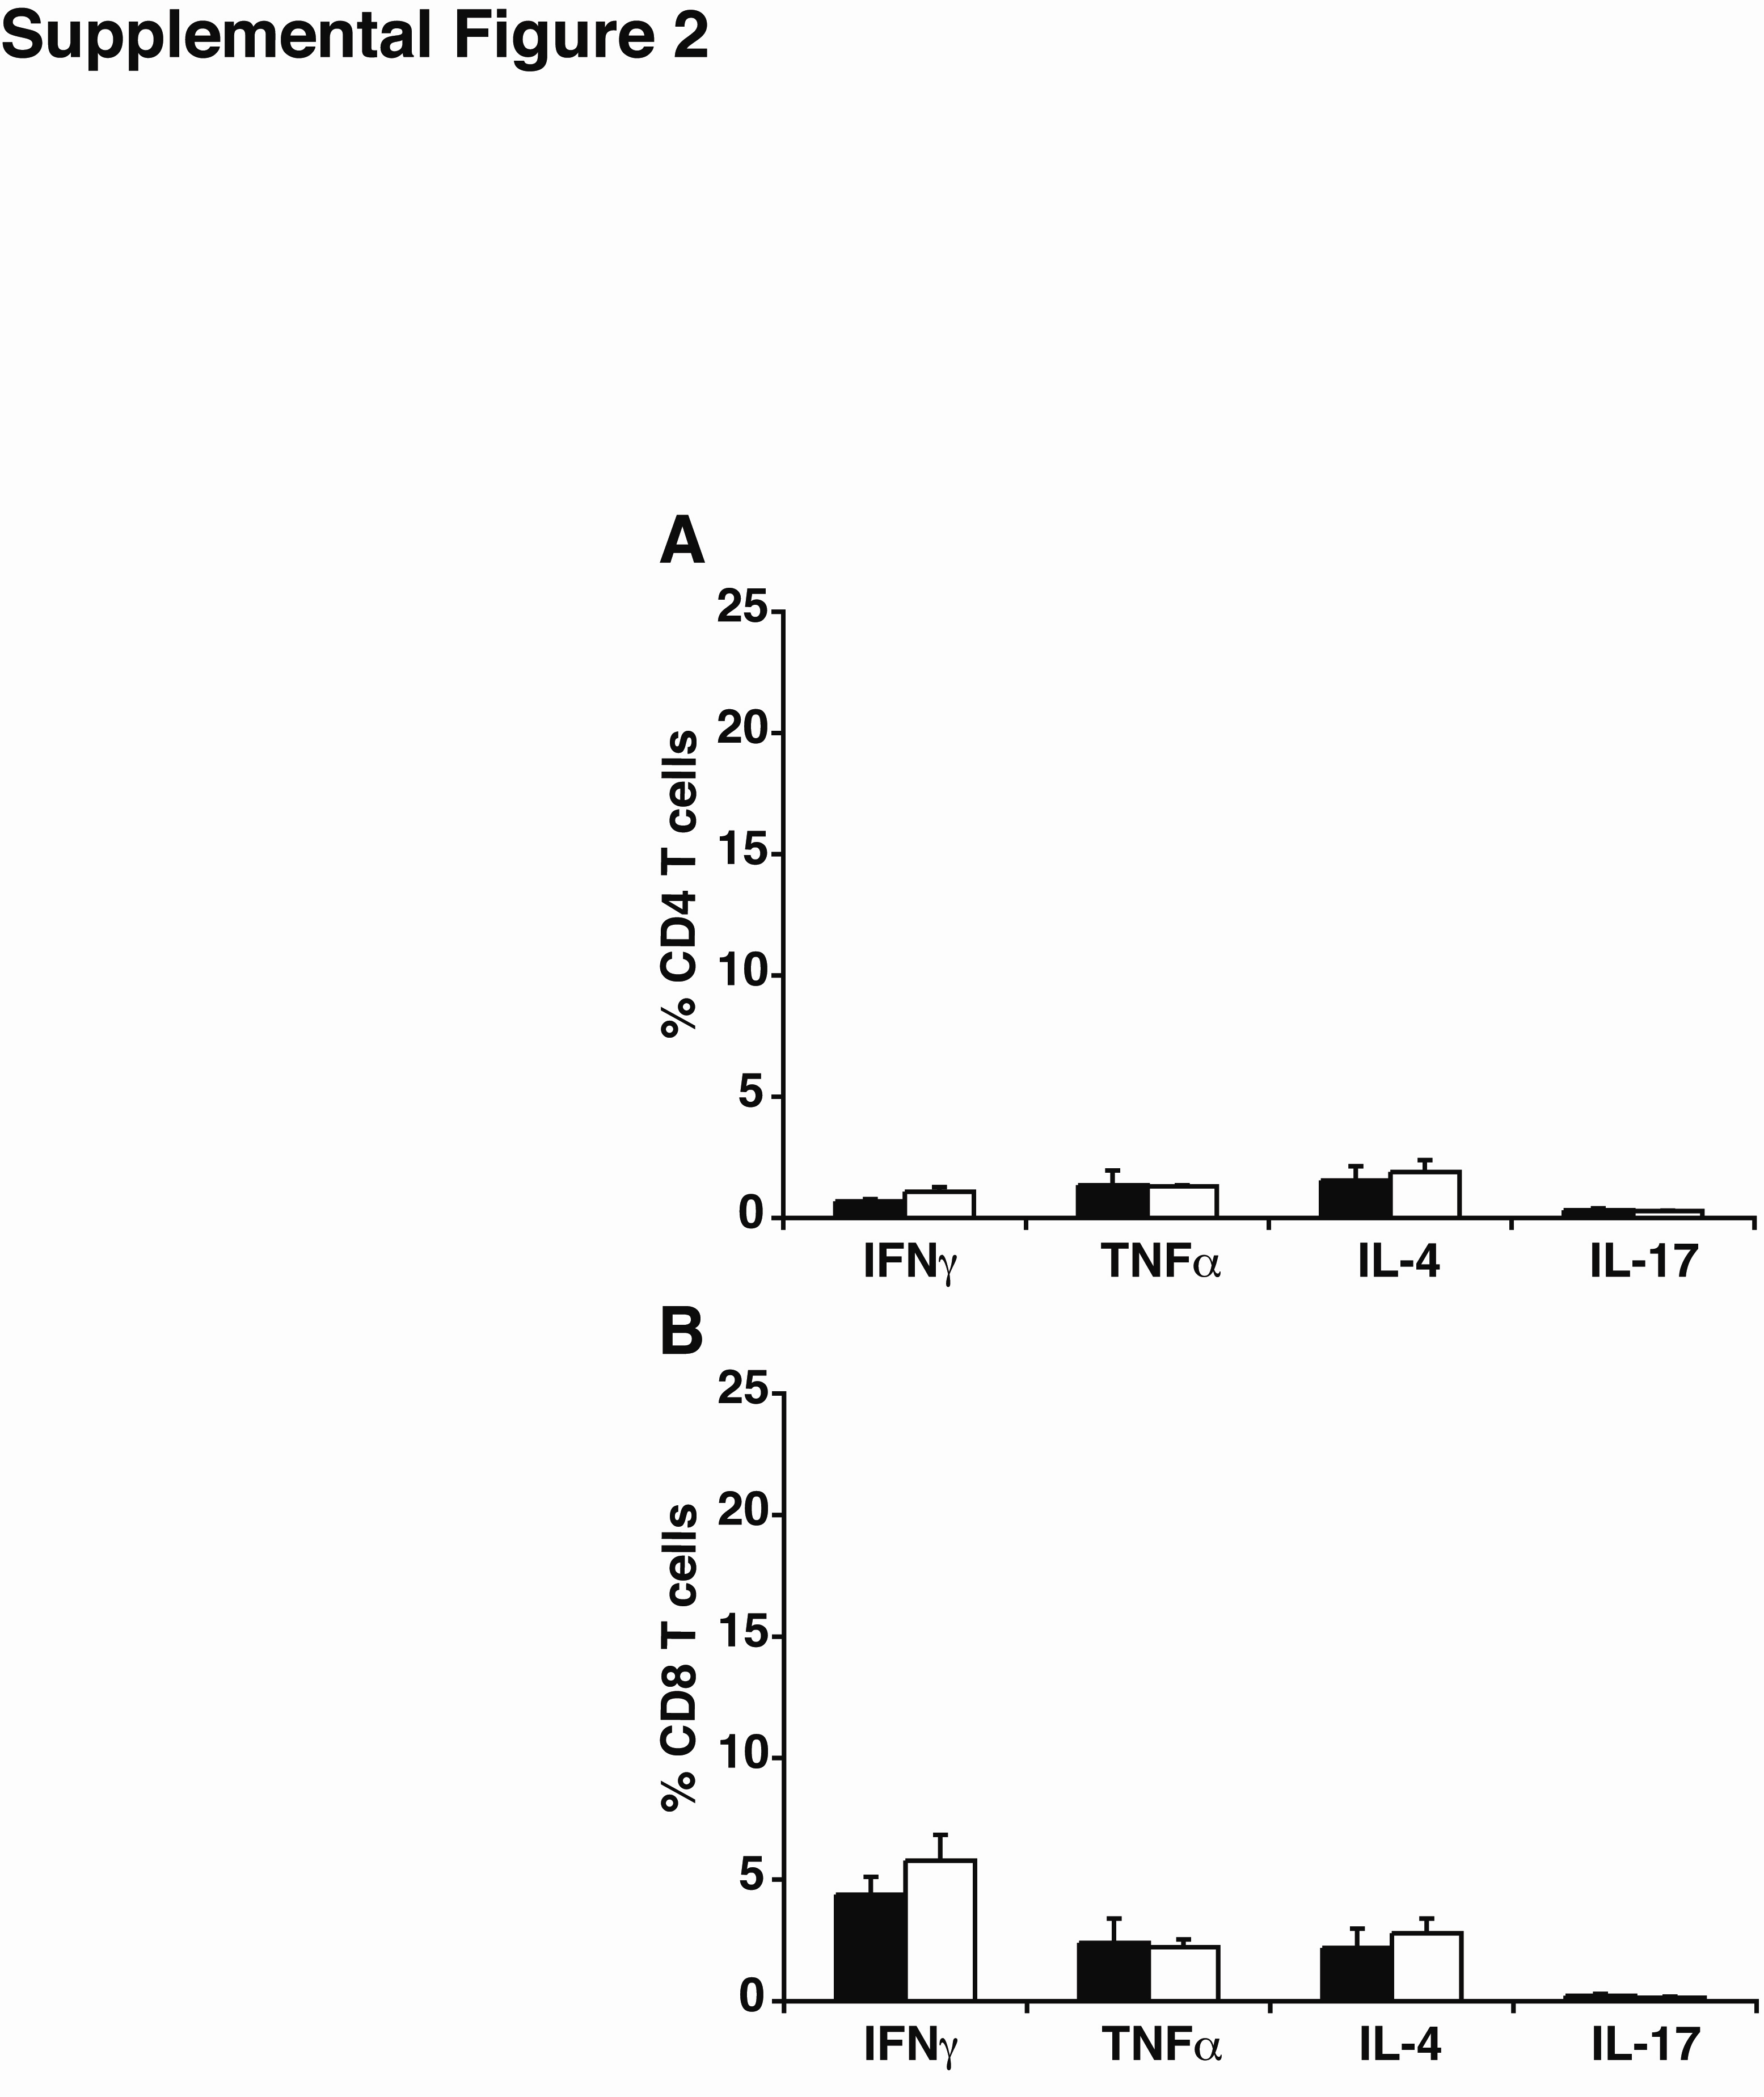
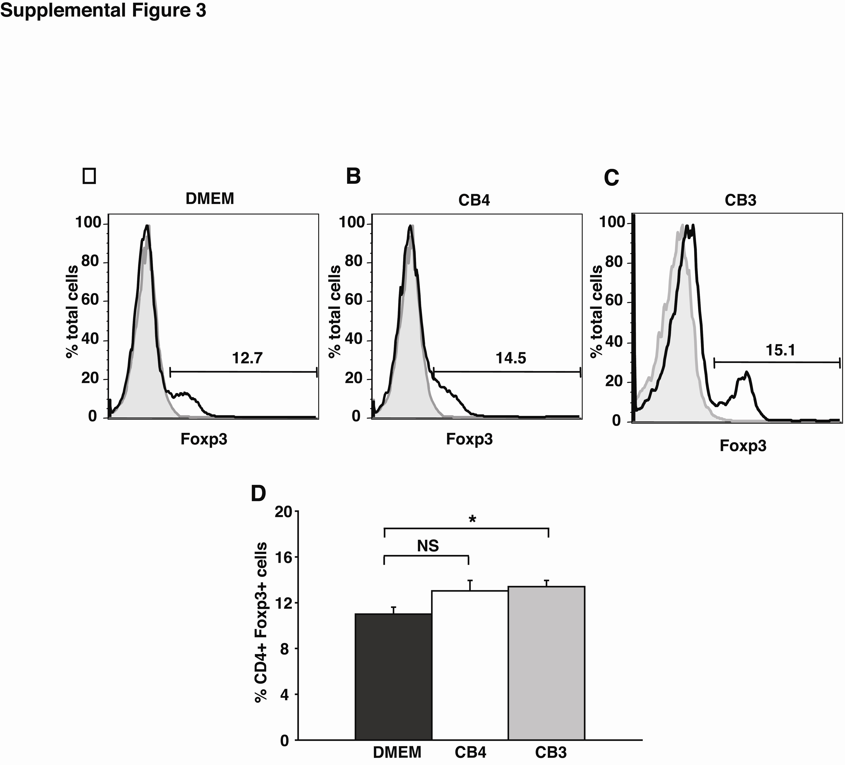
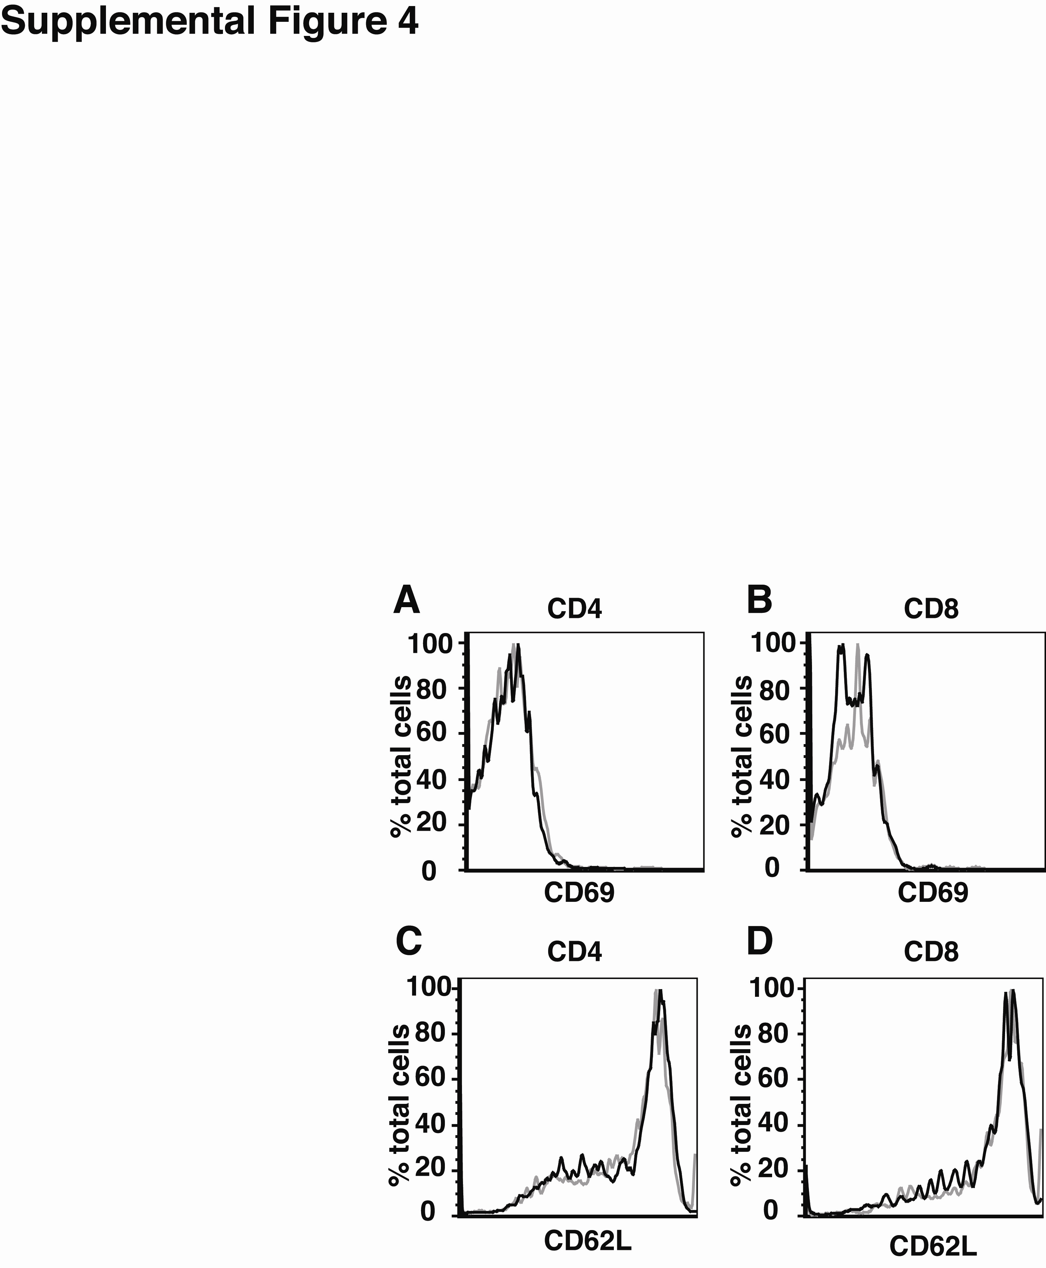
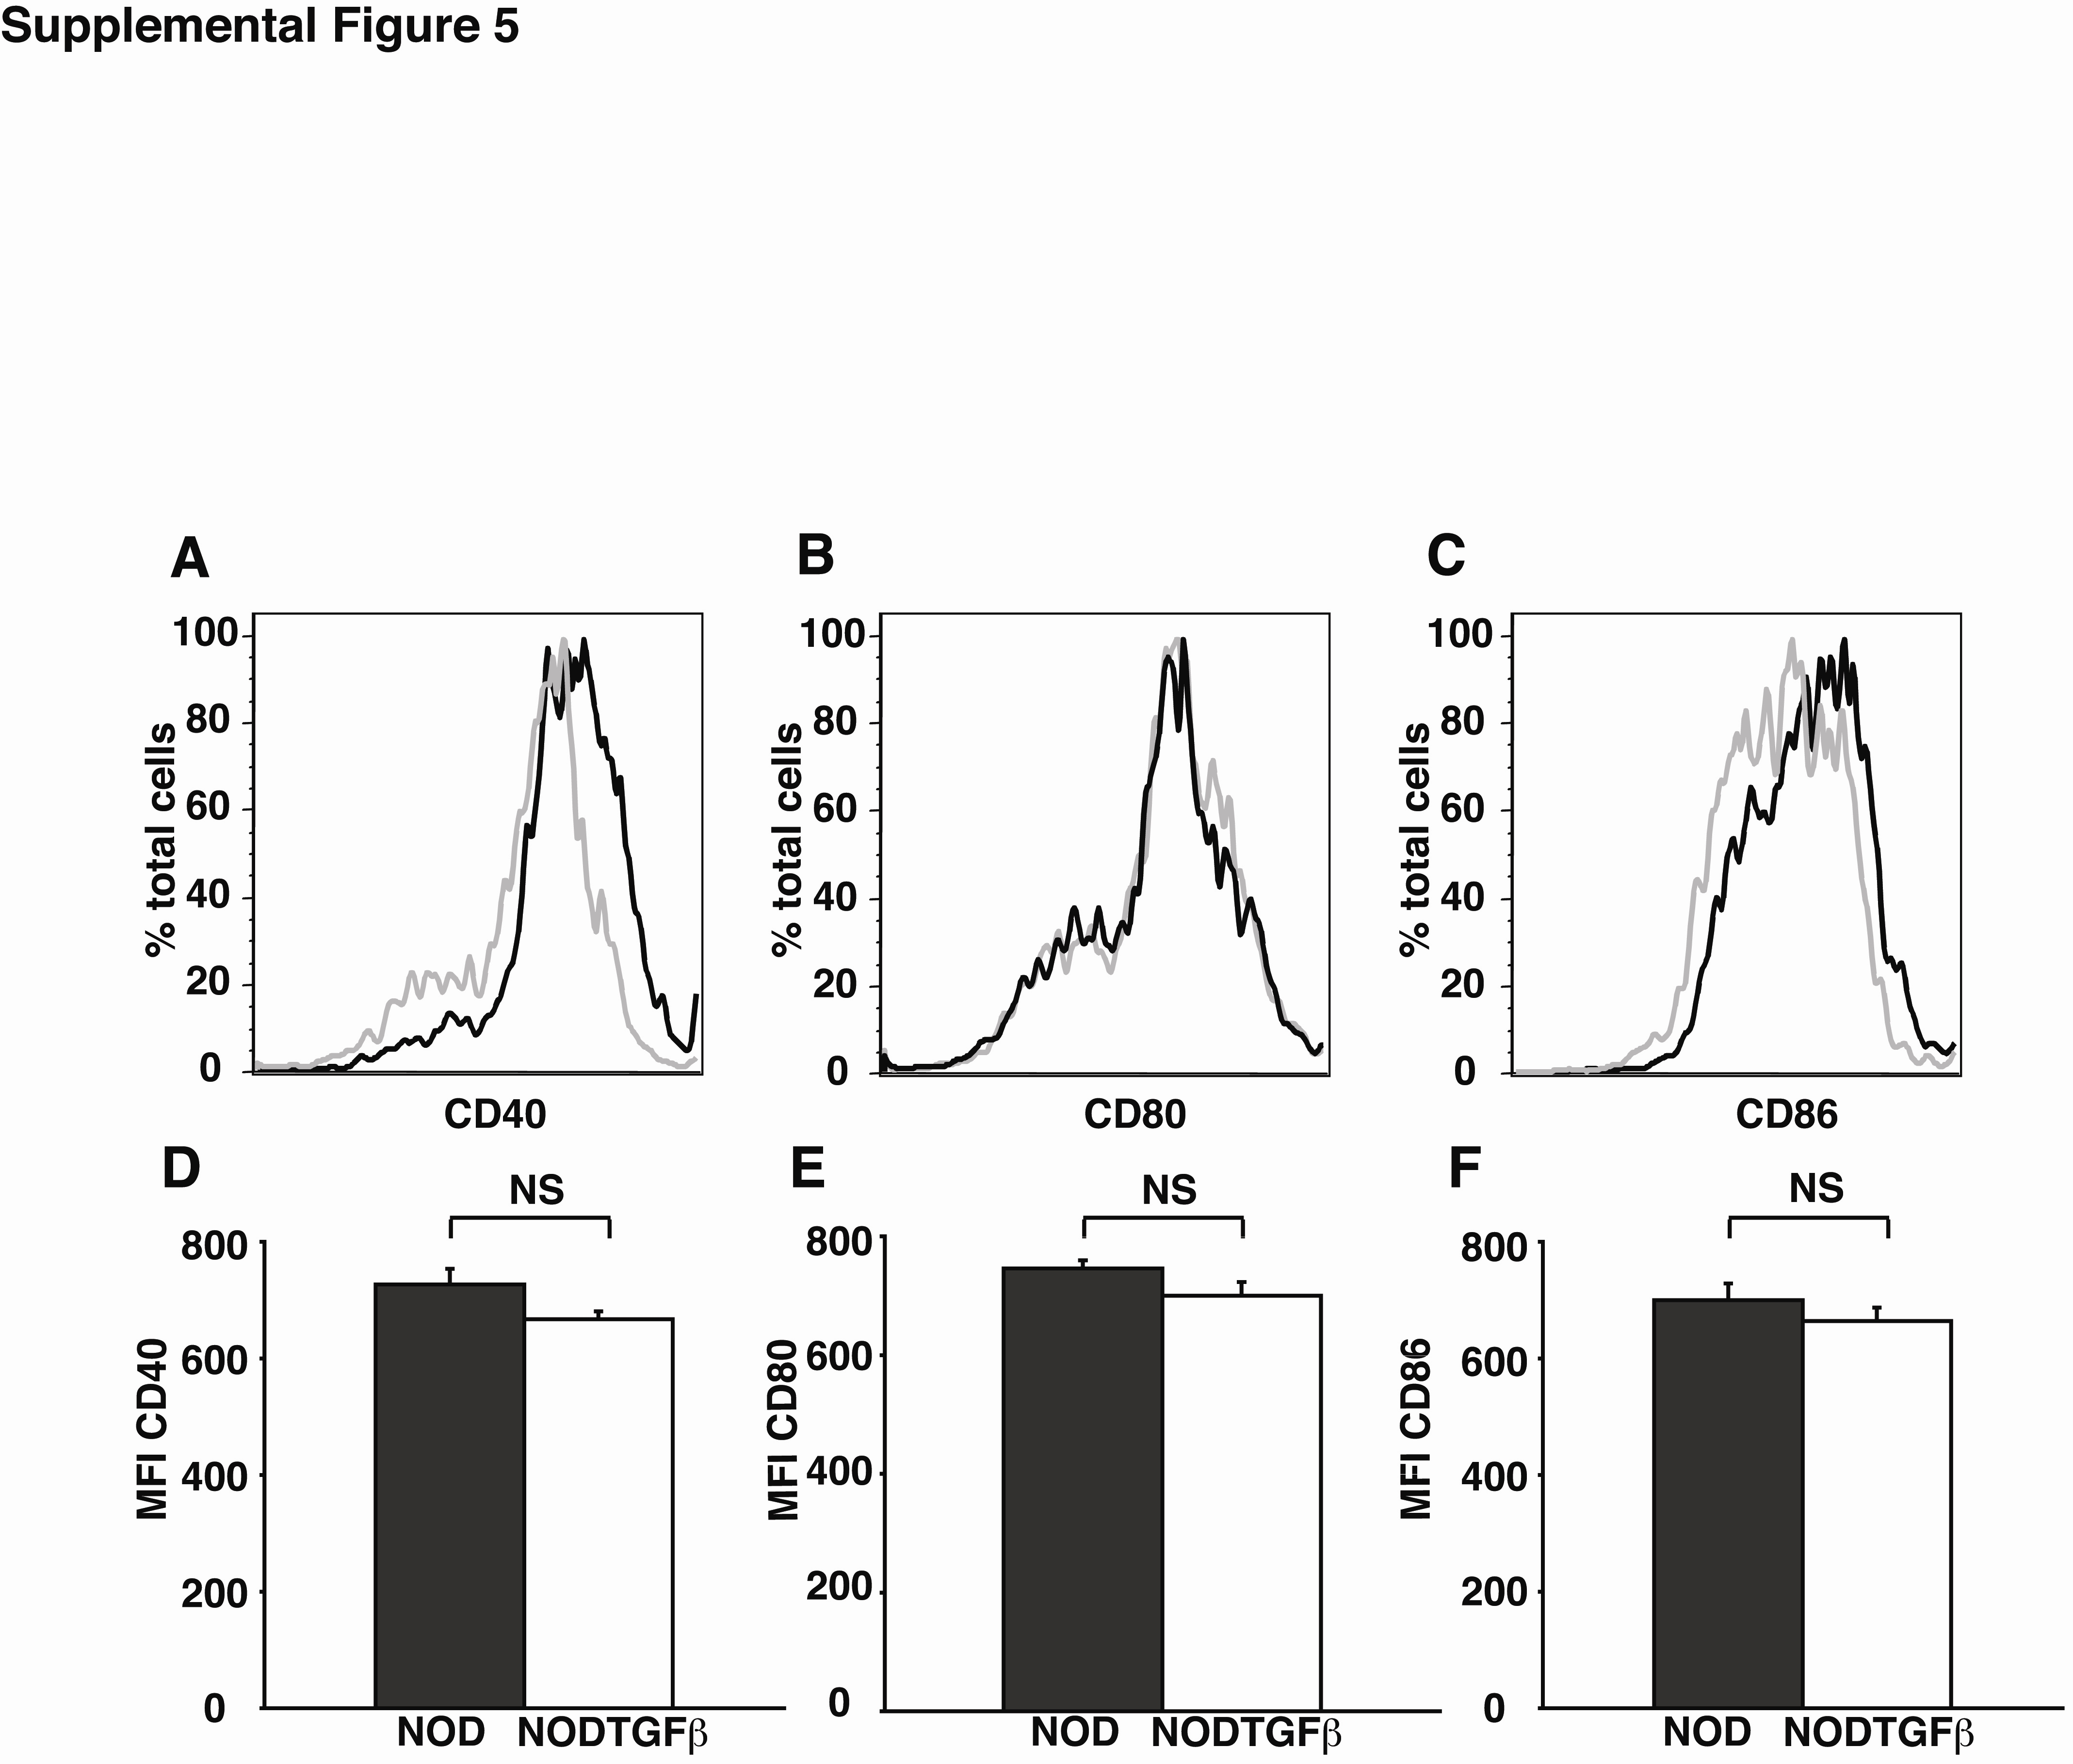
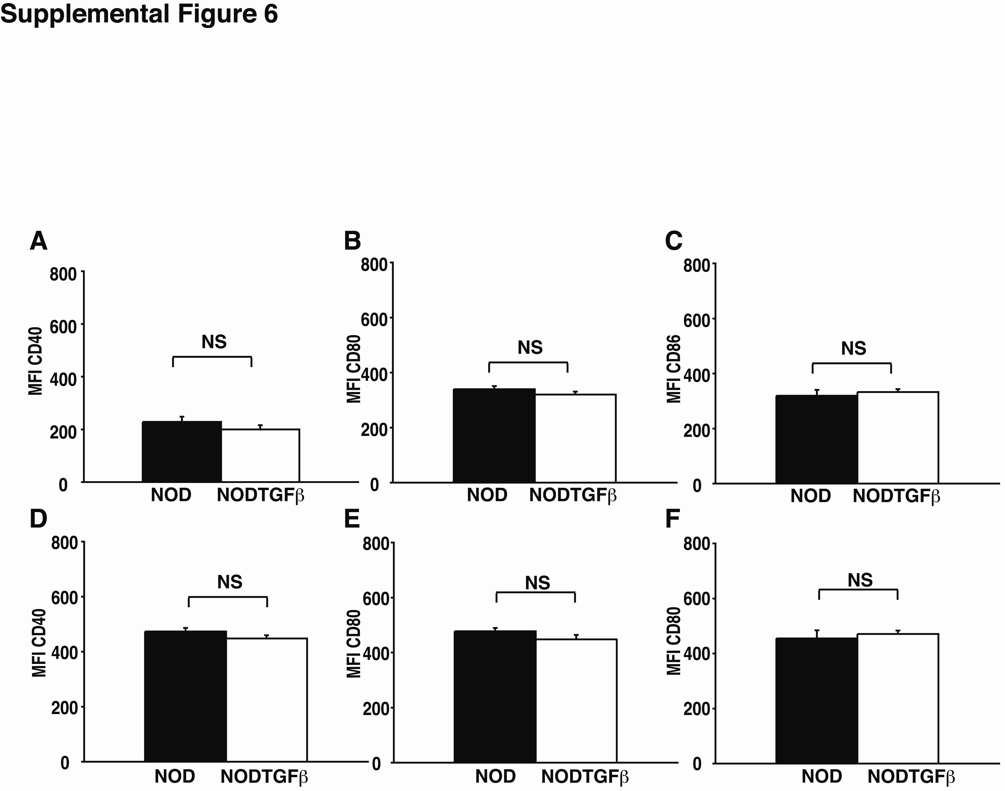
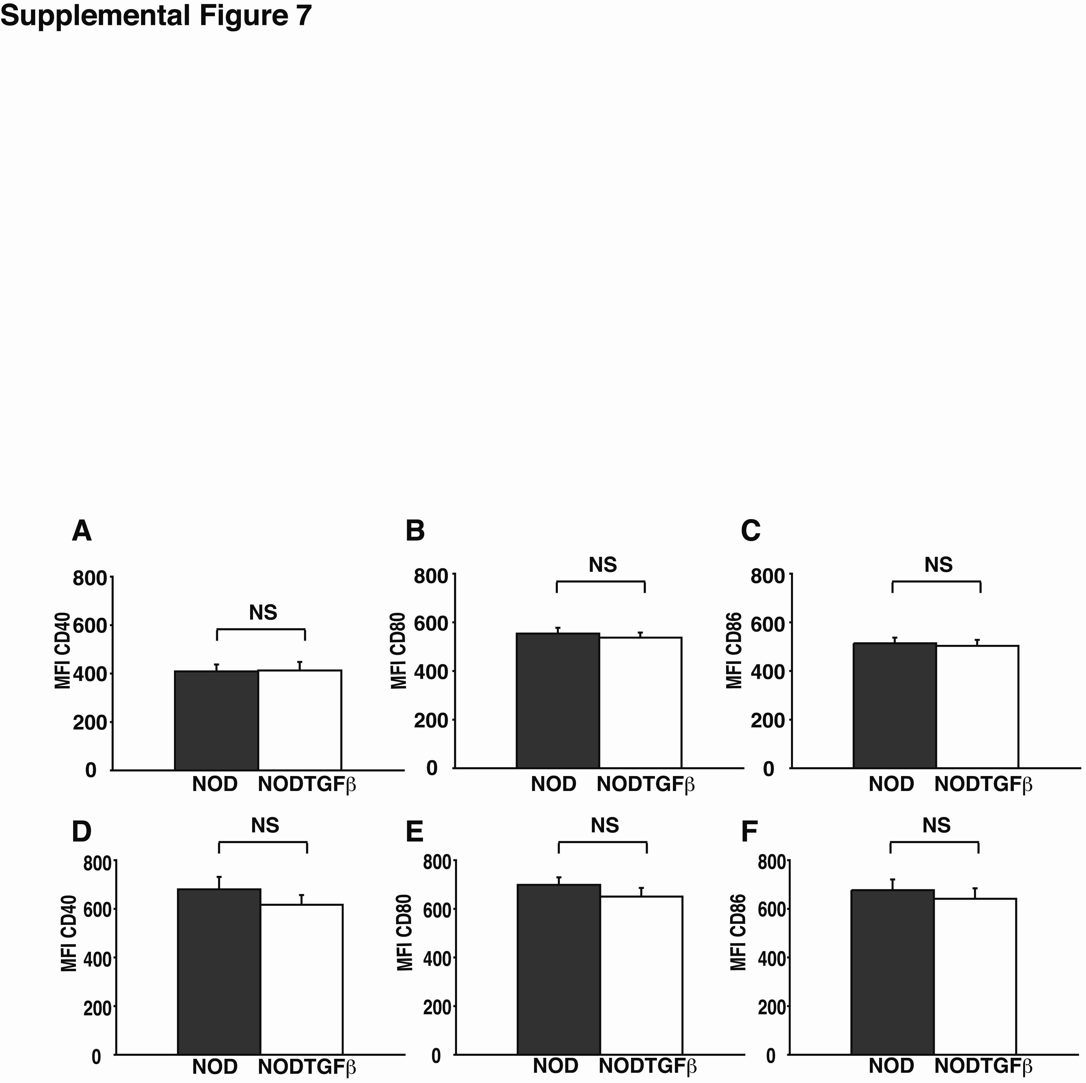
Supplemental Table 1: Histological analysis of pancreatic tissue of NOD and NODTGFβ mice 7 days following infection with CB4 or mock-infection with DMEM.


