Supplementary Table 2: Novel miRNAs cloned from e14.5 mouse pancreas.

miRNA | Sequence | x cloned | Mouse Genome Location | Strand |  | Rat | Dog | Human
btc 325 | TGAGAGGCAGAGAGCGAGACTTT | 1 | chr11:76,894,317-76,894,339 | - | 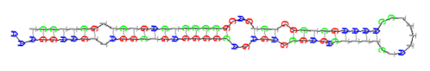 | + | + | +
14.5 486 | GAGGGTTGGGTGGAGGCTCTCCG | 1 | chr2:173,909,997-173,910,018 | - | 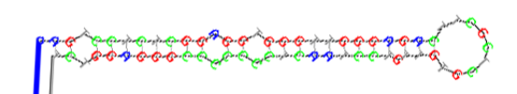 | + | + | +
14.5 438 | GCACTGAGATGGGAGTGGTGTAA | 1 | chr2:116,876,592-116,876,614 | + | 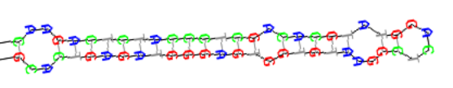 | + | - | -
14.5 307 | TGACACCTGCCACCCAGCCCAAGT | 1 | chr12:110,167,868-110,167,890 | + | 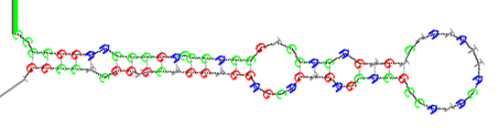 | + | - | -
14.5 388 | GATGAGAGCGCGGTACTGATGGC | 1 | chr7:130,338,153-130,338,175 | + | 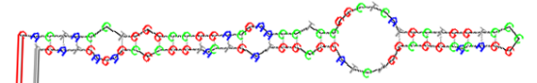 | + | + | +
14.5 2 427 | GCACTGAGATGGGAGTGGTGT | 1 | chr2:116,876,592-116,876,612 | + | 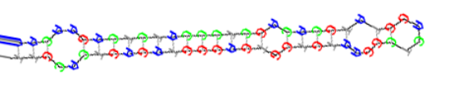 | + | - | -
14.5 2 425 | CTCACCTGGAGCATGTTTTC | 2 | chr13:21,904,396-21,904,415 | - | 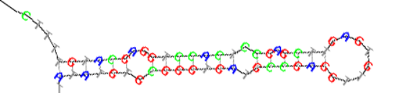 | + | - | -
14.5 2 380 | GCCCTAAGGTGAATTTTTTGGG | 1 | chr3:157,479,617-157,479,638 | + | 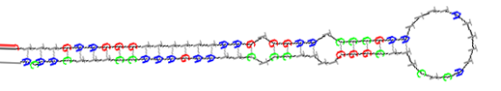 | + | + | +
14.5 2 27 | GGTGGTGCAGGCAGGAGAGCCA | 1 | chr7:100,756,453-100,756,474 | - | 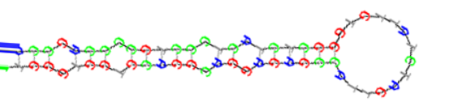 | + | - | -
14.5 2 250 | TATCGTCCTTCTGCCCAGCGAT | 1 | chr3:96,549,354-96,549,375 | - | 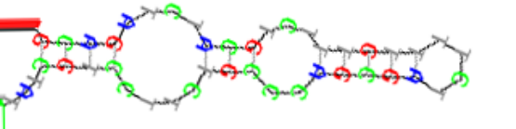 | + | - | -
14.5 2 222 | TGCCCCCTCCAGGAAGCCTTCT | 1 | chr12:110,195,735-110,195,756 | + | 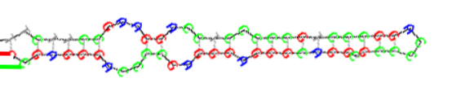 | + | - | +
14.5 2 192 | AAGACGGGAGAAGAGAAGGGAG | 2 | chr7:142,464,358-142,464,379 | - | 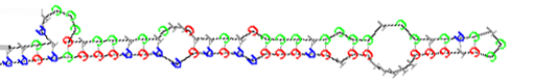 | + | + | +
14.5 2 155 | ACGGAGAGTCTTTGTCACTCAGT | 1 | chr16:93,258,315-93,258,337 | + | 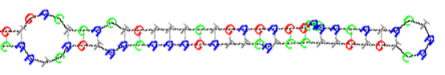 | + | + | +
14.5 2 135 | ACTAGATTGTGAGCTGCTGGAGT | 1 | chr16:24,743,258-24,743,279 | + | 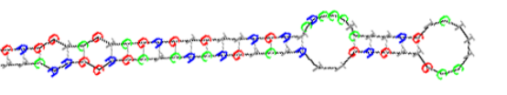 | + | + | +
14.5 454 | CACAGCTCCCATCTCAGAACAA | 1 | chr2:116,876,627-116,876,648 | + | 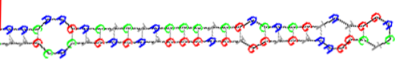 | + | - | -
14.5 142 | AAGGTTACTTGTTAGTTCAGGA | 2 | chr4:94,157,185-94,157,206 | + | 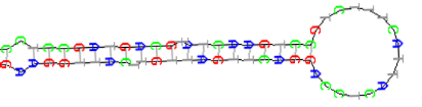 | + | + | -
14.5 99 | TCAGTAACAAAGATTCATCCTTGA | 1 | chr16:93,258,277-93,258,299 | + | 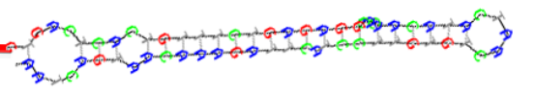 | + | + | +
14.5 91 | TGCAGTCCACGGGCATATACAC | 1 | chr4:62,743,264-62,743,285 | + |       

