Supplementary Appendix for:
Seeing Clearly: Effects of Initiatives to Improve Diabetic Retinopathy Screening at a Pediatric Center
Carol K.L. Lam, Stephen Zborovski, Mark R. Palmert, and Jennifer Harrington
DOI: https://doi.org/10.2337/cd18-0084. Published 12 Feb 2019]

Supplementary Data
- Supplementary Figure
- Supplementary Table

FIGURE 1. Rate of DRS. Run chart showing rates of DRS screening in eligible patients with type 1 diabetes (T1DM) at baseline and during intervention.
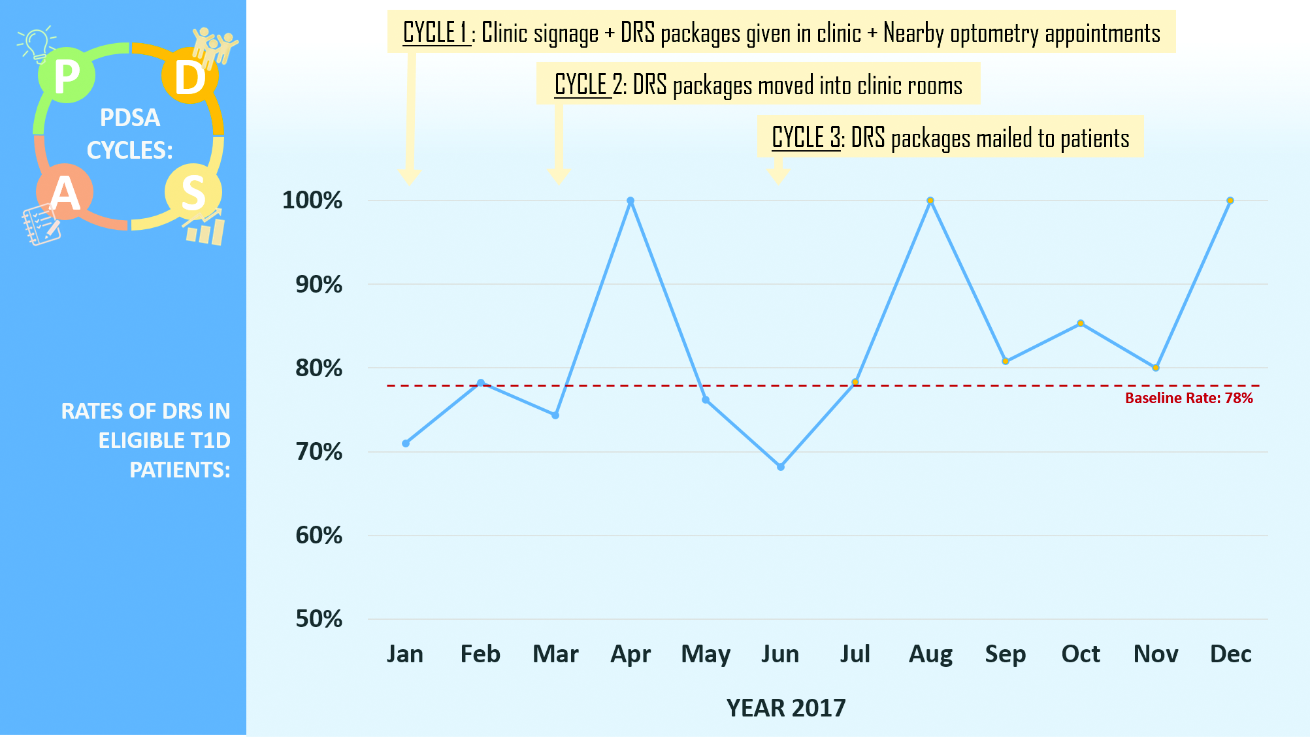

TABLE 1. Percentage of eligible patients with communication from eye care professional documented in the hospital’s EMR.
YEAR | PERCENT OF ELIGIBLE PATIENTS WITH COMMUNICATION FROM EYE CARE PROFESSIONAL IN HOSPITAL EMR
2015  (n = 120 eligible) | 6.3%
2016  (n = 127) | 6.7%
2017  (n = 126) | 16.7% (P <0.01)

