APPENDIX

1. Example of "report card" chart used in feedback on performance intervention. For this resident, the figure shows capillary glucose levels and provider actions during patient visits over the previous 6 months. Glucose was considered controlled in 38% of visits (< 150 mg/dl). Glucose was elevated and therapy was intensified in 24% of visits, but glucose was elevated and therapy was not intensified in 38% of visits.

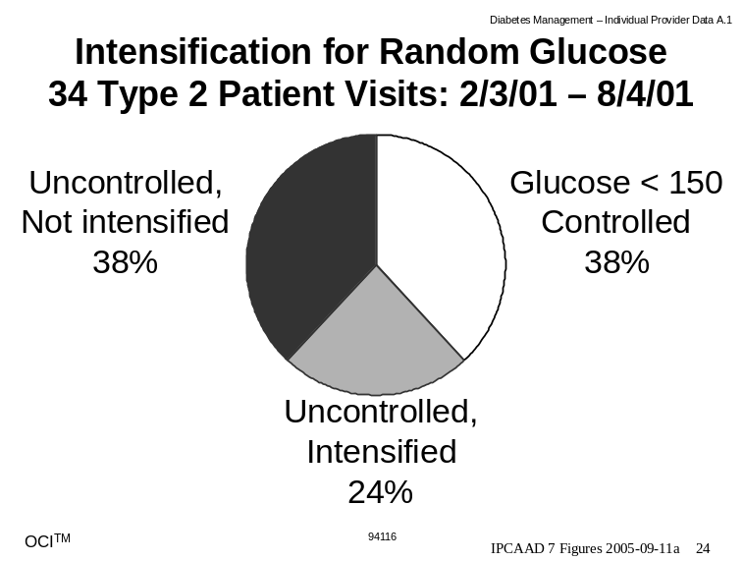

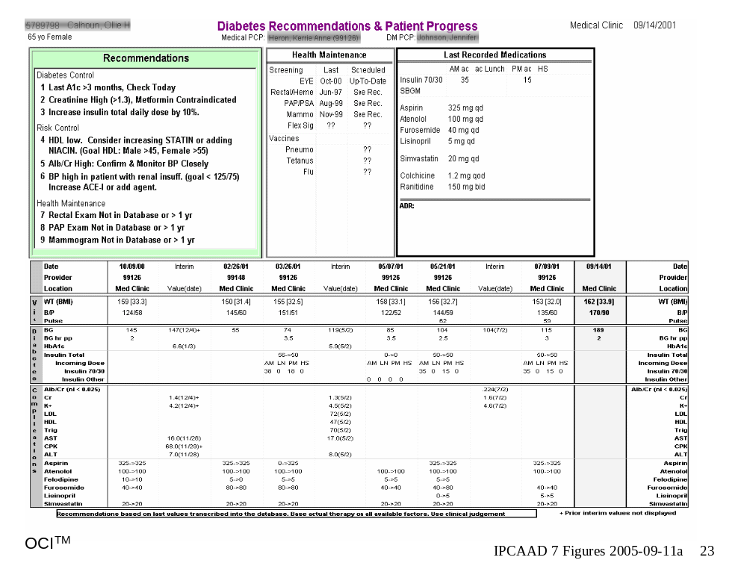2. Example of "computerized reminder" placed on patient charts. The lower panel is a flowsheet which shows physical findings, glucose and insulin, laboratory values, and medications for the previous several visits, and the current visit (on the right). The upper panel shows last recorded medications on the on the right, health maintenance activities in the middle, and individualized patient- and visit-specific recommendations for management on the left.

